相同Gene name 不同majority id
Gene name | Majority id in 45sample | Majority id in 178 sample

相同 majority id 不同 gene name
Majority id | Gene name in 45 sample | Gene name in 178 sample
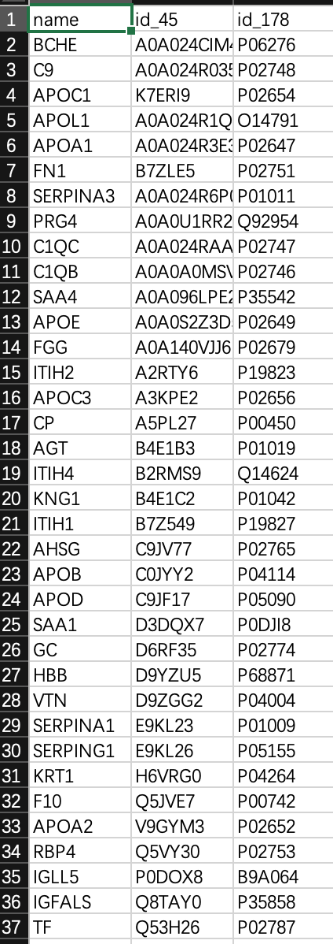

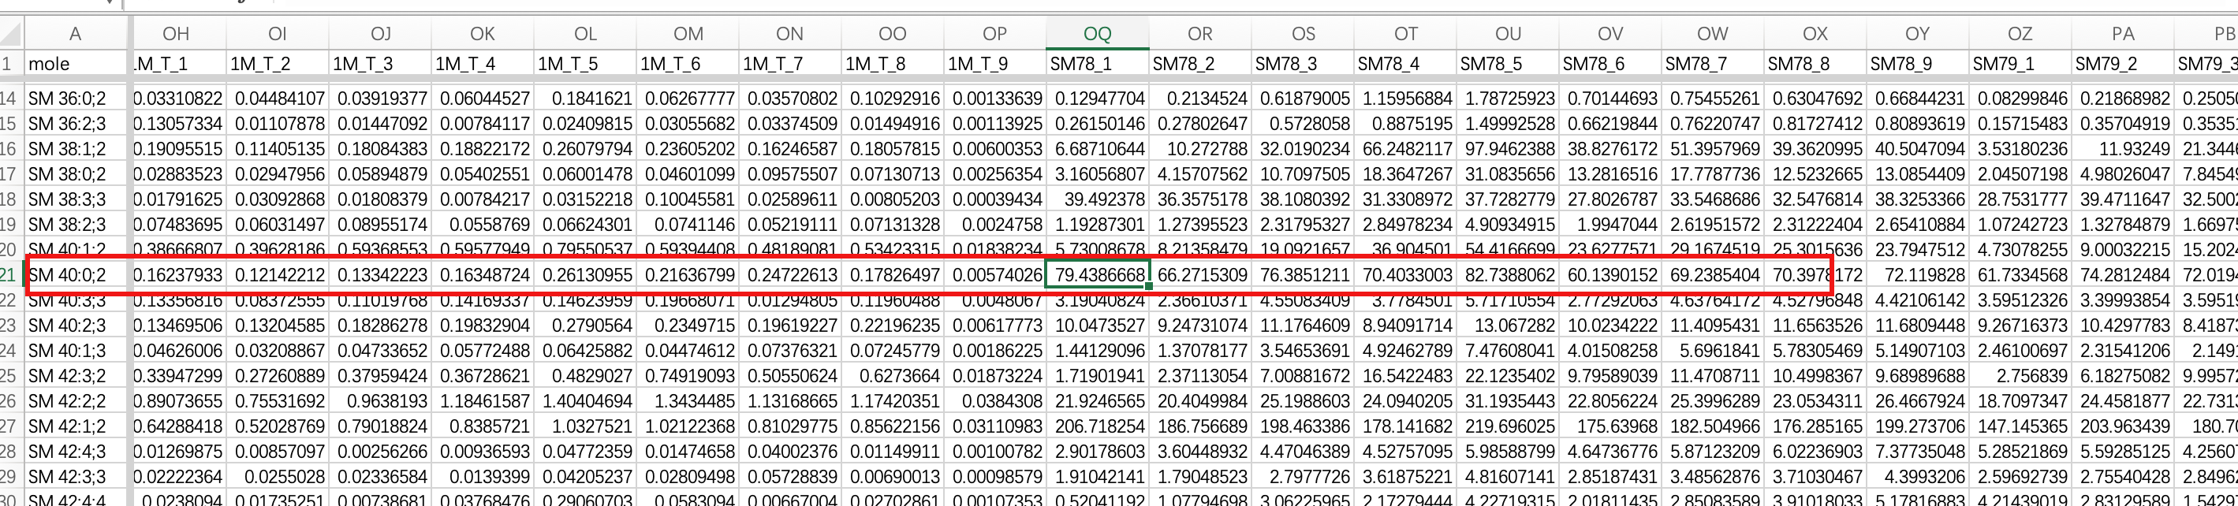

相关系数类型\n1-pearson\n2-spearman\n3-mic\n4-moleF\n5-self-pearson\n6-self-spearman\n7-self-mic

分类类型\n1-60 sample clusterCEC\n2- clinic diagnosis\n3- all sample cluster\n

SM1:
SM 38:0;2
4.838296555, 7.387188607, 10.95589775, 10.7679646, 6.833505369, 6.866195622, 5.961670233, 5.928309714, 6.829297614

SM 40:1;2
10.55339545,18.40830509,24.50033625,24.56902346,15.87589981,15.51965128,12.59166845,13.76816255,14.93092455

VTN
48931,85635,81676,159030,88610,146980,198030,299890,296730

SM10:
SM 38:0;2
6.406429546, 7.139730364, 8.574757579, 12.58279159, 8.218535585, 6.875563021, 6.305888112, 6.127091698, 5.923667169
SM 40:1;2
15.2378891, 18.63417392, 21.37766384, 29.43816843, 20.28724024, 16.83977926, 15.1434235, 14.77209645, 16.19596927
VTN:
31060, 35750, 35208, 82516, 86061, 63802, 100220, 73609, 85125

SM100:
SM 38:0;2
3.126579476, 6.055979536, 9.70846172, 20.36742088, 14.27118724, 10.84767481, 8.778097551, 9.392330482, 7.743443052
SM 40:1;2
5.351971823, 9.433439874, 16.30507678, 35.16987843, 23.93827175, 20.90745822, 14.91689226, 15.06950733, 12.07070961
VTN
111300, 131280, 124180, 232530, 273880, 184560, 216930, 315740, 364160

脂质变化很小，蛋白和脂质分开算，（只算蛋白质的相关性），按照模块去算

先筛选一下（按照Apoa高和低的两类，把两组有差别的相关性先保留，无差异的去掉，或者按照正常人与病人相对比）
Gensini评分0的可认为是对照

蛋白质系数明确
功能模块系数

