- Ex1: 若将y←uniform(0,1)改为y←x，则上述的算法估计的值是什么？
此时x和y的取值相等，真实的$\frac{k}{n}=\frac{{\sqrt{2}}/2}{1}$，带入原公式$\frac{k}{n}=\frac{π}{4}$，得$π=2\sqrt{2}$.
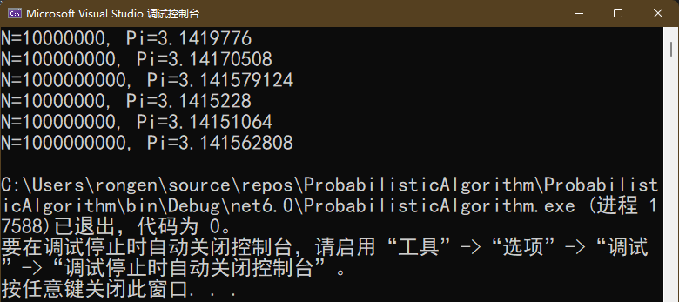
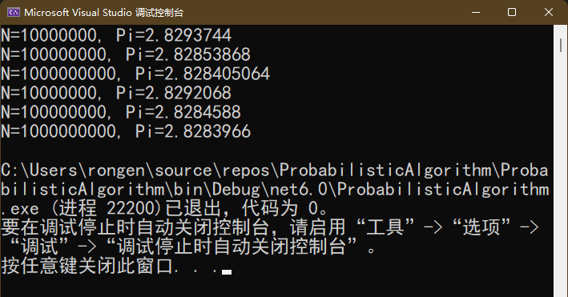
- Ex2：在机器上用$4\int_{0}^{1}{\sqrt{1-x^{2}}dx}$估计π值，给出不同的n值及精度。
四次的结果比较：
N=1000,Pi=3,一位精度，
N=1000000,Pi=3.14,三位精度
N=100000000,Pi=3.141,四位精度
N=1000000000,Pi=3.14115,五位精度
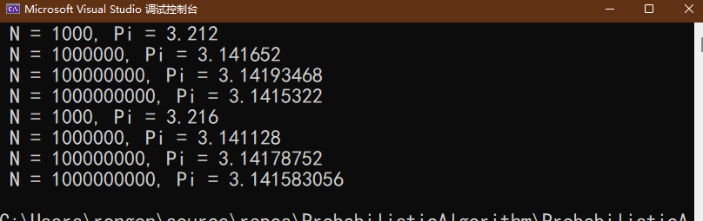
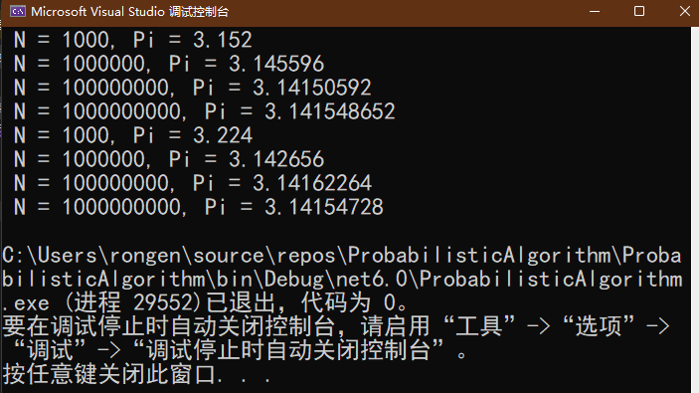
- Ex3：设a, b, c和d是实数，且a ≤ b, c ≤ d, f:[a,b] → [c, d]是一个连续函数，写一概率
算法计算积分：$\int_{a}^{b}{f(x)dx}$，注意，函数的参数是a, b, c, d, n和f, 其中f用函数指针实现，请选一连续函数做实验，并给出实验结果。
选择f(x)=sin(x), a=1, b=3*Pi, c=-1, d=1, 结果如下：
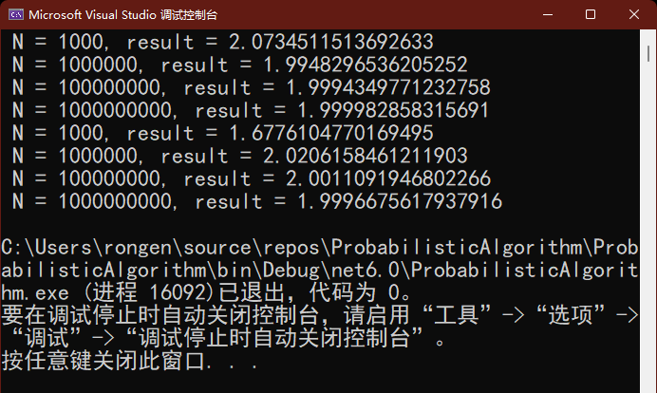

- EX. 用上述算法，估计整数子集1~n的大小，并分析n对估计值的影响。
重复5W次取平均值的结果，先求平均的k，再计算2*k*k/pi，误差较小，当集合足够大时，误差在1%以内：
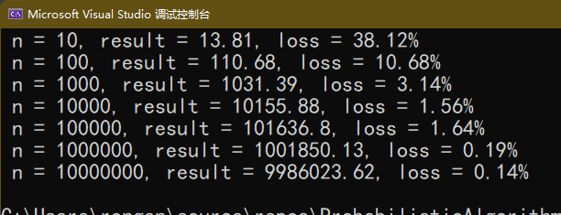
- Ex. 分析dlogRH的工作原理，指出该算法相应的u和v。
随机抽样函数：$r=uniform(0..p-2)$
将输入实例转化为随机化的实例：$u\left(g,a,p,r\right)=\left(g,ag^{r}mod p,p\right)$
将随机化实例的输出转化为原实例的输出：$v\left(y,r,p\right)=\left(y-r\right)mod\left(p-1\right)$
原理：$g^{\left(y-r\right)mod(p-1)}mod p=g^{y-r}mod p=g^{\left(r+x\right)-r}mod p=g^{x}mod p$
$ag^{r}mod p=g^{x}mod p*g^{r}mod p=g^{x+r}mod p=g^{\left(x+r\right)mod \left(p-1\right)}mod p$
- Ex. 写一Sherwood算法C，与算法A, B, D比较，给出实验结果。
在有序和随机链表上重复1000次随机数的查找，四种算法的实验结果如下：
随机链表：
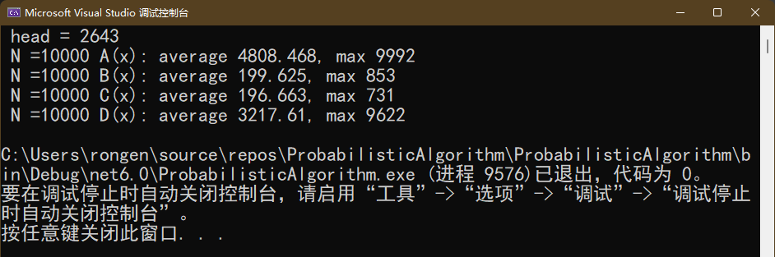
顺序链表：
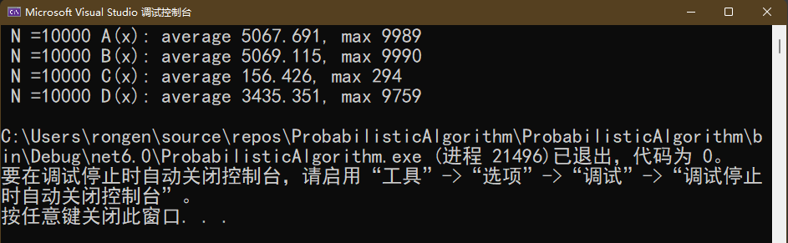

- Ex.证明：当放置（k+1)th皇后时，若有多个位置是开放的,则算法QueensLV选中其中任一位置的概率相等。
证明：设共有m个开放的位置。要证明QueensLV选择其中任一位置的概率相等，只要证明：对任意t=1,2,…,m，第t个开放位置被选中的概率为$\frac{1}{m}$。
第t个开放位置若最终被选中，则第t轮之前的随机没有影响，需要在第t轮随机出uniform(1..t)=1，并且第t+1到m轮都未选中（随机uniform出的值不为1）.第t轮随机出uniform(1..t)=1的概率为$\frac{1}{t}$，第t+1到m轮随机出不为1的概率依次为$\frac{t}{t+1}$, $\frac{t+1}{t+2}$, …, $\frac{m-1}{m}$。
因此，最终选中t的概率为 $\frac{1}{t}·\frac{t}{t+1}·\frac{t+1}{t+2}·…·\frac{m-2}{m-1}·\frac{m-1}{m}=\frac{1}{m}$，证毕。
- Ex. 写一算法，求n=12~20时最优的StepVegas值。
每个n对0到n的K值重复计算5000次，取平均值作为n-K节点数，选择最少的K为最优，分别对应的bestK和结点数如下：
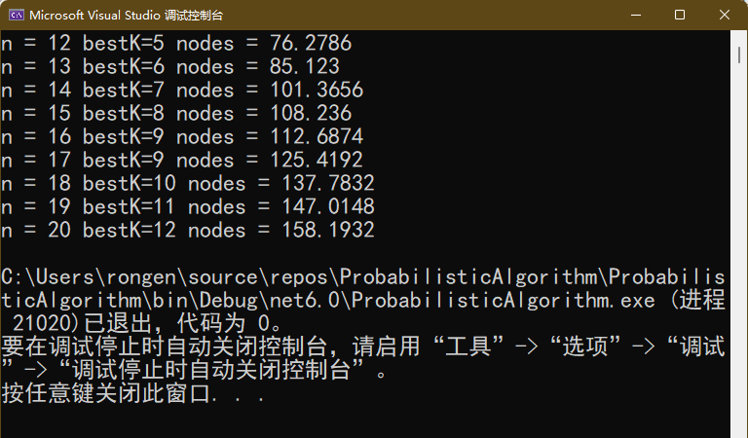

- 用RepeatMilRab打印1万以内的素数，与确定性算法相比较，并给出100~10000以内
错误的比例。
当k取lg n时，重复运行10000次，有2419个判断出错，约0.0024%错误：
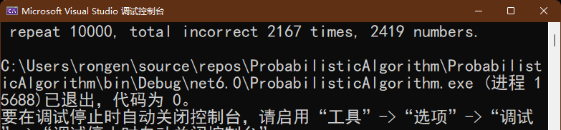
K取100时，重复运行10000次，没有判断错误：
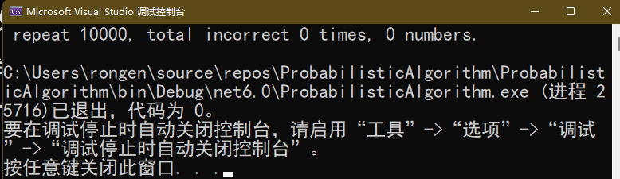

实验代码地址：https://github.com/xdober/ProbabilisticAlgorithm

实验代码，环境 .NET 6.0：
HitOrMiss.cs:
using System;
using System.Collections.Generic;
using System.Linq;
using System.Text;
using System.Threading.Tasks;
namespace ProbabilisticAlgorithm
{
static class HitOrMiss
{
private static readonly object countLock = new object();
public static double Darts(int n)
{
int k = 0;
double x = 0, y = 0;
var seed = Guid.NewGuid().GetHashCode();
var rand = new Random(seed);
for (int i = 0; i < n; i++)
{
x = rand.NextDouble();
y = rand.NextDouble();
if (x * x + y * y <= 1)
{
k++;
}
}
return 4.0 * k / n;
}
public static double Darts2(int n)
{
int k = 0;
double x = 0, y = 0;
var seed = Guid.NewGuid().GetHashCode();
var rand = new Random(seed);
for (int i = 0; i < n; i++)
{
x = rand.NextDouble();
y = x;
if (x * x + y * y <= 1)
{
k++;
}
}
return 4.0 * k / n;
}

private static double F(double x)
{
return Math.Sqrt(1 - (x * x));
}
/// <summary>
/// Monte Carlo积分计算pi
/// </summary>
/// <param name="n"></param>
/// <returns></returns>
public static double MCCalculus(int n)
{
var seed = Guid.NewGuid().GetHashCode();
var rand = new Random(seed);
int k = 0;
double x = 0, y = 0;
for (int i = 0; i < n; i++)
{
x=rand.NextDouble();
y=rand.NextDouble();
double fx = F(x);
if (y < fx)
{
k++;
}
}
return 4.0 * k / n;
}

private static double Sin(double x)
{
return Math.Sin(x);
}
/// <summary>
/// 求ff(x)在[a,b]的定积分
/// </summary>
/// <param name="a"></param>
/// <param name="b"></param>
/// <param name="c"></param>
/// <param name="d"></param>
/// <param name="n"></param>
/// <param name="func"></param>
/// <returns></returns>
public static double CalculusF(double a, double b, double c, double d, int n, Func<double,double> func)
{
var seed = Guid.NewGuid().GetHashCode();
var rand = new Random(seed);
int k = 0;
double x = 0, y = 0, fx=0;
double total = (b-a)*(d-c);
for(int i = 0; i < n; i++)
{
x= rand.NextDouble();
x = x * (b - a) + a;//x映射到定义域
y= rand.NextDouble();
y = y * (d - c) + c;//y映射到f(x)值域
fx = func(x);
if(0 < y && y < fx && fx>0)
{
k++;
}
if (0 > y && y > fx && fx < 0)
{
k--;
}
}
return total * k / n;
}

/// <summary>
/// 集合元素数量
/// </summary>
/// <param name="x"></param>
/// <returns></returns>
public static decimal SetCount(int x, int n)
{
decimal result = 0;
for (int i = 0; i < n; i++)
{
var tmp = InternalSetCount(x);
result += tmp;
}
var k = result / n;
return 2 * k * k / (decimal)Math.PI ;
}
/// <summary>
/// 并行估算集合元素数量
/// </summary>
/// <param name="x"></param>
/// <param name="n"></param>
/// <returns></returns>
public static decimal ParallelSetCount(int x, int n)
{
decimal cnt = 0;
Parallel.For(0, n,
index =>
{
var tmp = InternalSetCount(x);
lock(countLock){
cnt += tmp;
}
});
var k = cnt / n;
return 2 * k * k / (decimal)Math.PI;
}

public static decimal InternalSetCount(int x)
{
int[] arr=Enumerable.Range(1, x).ToArray();
int k = 1;
var seed = Guid.NewGuid().GetHashCode();
var rand = new Random(seed);
var tmp = new List<int>(arr[rand.Next(0,x)]);
int min = x, max = 0;
while (true)
{
int r = rand.Next(0,x);
if(r < min)
{
min = r;
}
if(r > max)
{
max = r;
}
if (tmp.Contains(arr[r]))
{
break;
}
else
{
tmp.Add(arr[r]);
k++;
}
}
return k;

}
}
}

SearchOrderList.cs:
using System;
using System.Collections.Generic;
using System.Diagnostics;
using System.Linq;
using System.Text;
using System.Threading.Tasks;

namespace ProbabilisticAlgorithm
{
static class SearchOrderList
{
public static void Search(int n, int repeat)
{
var searchInstance = new SearchList(n);
int x;
decimal[] counts = new decimal[4];
int[] maxCount = Enumerable.Repeat(0, 4).ToArray();
string[] algorithmName = { "A(x)", "B(x)", "C(x)", "D(x)", };
for(int i = 0; i < repeat; i++)
{
x = searchInstance.rand.Next(0, n) * 2;
var retA = searchInstance.SearchA(x);
counts[0] += retA.Item2;
if(maxCount[0] < retA.Item2)
{
maxCount[0] = retA.Item2;
}
var retB = searchInstance.SearchB(x);
counts[1] += retB.Item2;
if(maxCount[1] < retB.Item2)
{
maxCount[1] = retB.Item2;
}
var retC = searchInstance.SearchC(x);
counts[2] += retC.Item2;
if(maxCount[2] < retC.Item2)
{
maxCount[2] = retC.Item2;
}
var retD = searchInstance.SearchD(x);
counts[3] += retD.Item2;
if(maxCount[3] < retD.Item2)
{
maxCount[3] = retD.Item2;
}
}

for(int i = 0; i < 4; i++)
{
Console.WriteLine($" N ={n} {algorithmName[i]}: average {counts[i]/repeat}, max {maxCount[i]}");
}
}
}

public class SearchList
{
private int[] val;
private int[] ptr;
private int[] revptr;
private int[] rank;
private int head;
private int len;
public Random rand;
public SearchList(int n)
{
val = Enumerable.Range(0, n).ToArray();
Array.ForEach(val, (i) => { val[i] *= 2; });
ptr = Enumerable.Range(1, n).ToArray();
ptr[n-1] = 0;
revptr = Enumerable.Range(-1, n).ToArray();

rank = new int[n];
Array.ConstrainedCopy(val, 0, rank, 0, n);
head = 0;
len = n;

rand = new Random(Guid.NewGuid().GetHashCode());
//Shuffle();

}
/// <summary>
/// 将链表打乱顺序，并保证ptr的正确性
/// </summary>
private void Shuffle()
{
int tmpi,tmpVal,tmpPtr,tmpRev;
for(int i = 0; i < len; i++)
{
tmpi = rand.Next(i,val.Length);

if (tmpi == i)
{
continue;
}
//swap val[i] and val[tmpi]
tmpVal = val[i];
val[i] = val[tmpi];
val[tmpi] = tmpVal;

// i与i后面交换
if(tmpi == ptr[i])
{

if (revptr[i] >= 0)
{
ptr[revptr[i]] = tmpi;
}
if (ptr[tmpi]!=0)
{
revptr[ptr[tmpi]] = i;
}
tmpPtr = ptr[tmpi];
ptr[tmpi] = i;
ptr[i] = tmpPtr;

revptr[tmpi] = revptr[i];
revptr[i] = tmpi;

}
// i与i前面交换
else if (tmpi == revptr[i])
{
ptr[tmpi] = ptr[i];
ptr[i] = tmpi;

revptr[i] = revptr[tmpi];
revptr[tmpi] = i;

revptr[ptr[tmpi]] = tmpi;
if(revptr[i] >= 0)
{
ptr[revptr[i]] = i;
}

}
else
{
//swap ptr
tmpPtr = ptr[tmpi];
ptr[tmpi] = ptr[i];
ptr[i] = tmpPtr;

//swap revPtr
tmpRev = revptr[i];
revptr[i] = revptr[tmpi];
revptr[tmpi] = tmpRev;
if (revptr[tmpi] >= 0)
{
ptr[revptr[tmpi]] = tmpi;
}
if (revptr[i] >= 0)
{
ptr[revptr[i]] = i;
}
revptr[ptr[tmpi]] = tmpi;
revptr[ptr[i]] = i;

}

if(revptr[i] == -1)
{
head = i;
}
else if (revptr[tmpi] == -1)
{
head = tmpi;
}

}
Console.WriteLine($" head = {head}");
}
private Tuple<int, int> Search(int x, int i)
{
int k = 0;
while(x > val[i])
{
i = ptr[i];
k++;
}
return new Tuple<int, int>(i, k);
}

/// <summary>
/// algorithm A
/// </summary>
/// <param name="x"></param>
/// <returns></returns>
public Tuple<int, int> SearchA (int x)
{
return Search(x, head);
}

/// <summary>
/// algorithm D
/// </summary>
/// <param name="x"></param>
/// <returns></returns>
public Tuple<int, int> SearchD(int x)
{
int i = rand.Next(0, len);
int y = val[i];
if (x > y)
{
return Search(x,ptr[i]);
}
else if (x < y)
{
return Search(x, head);
}
else
{
return new Tuple<int, int>(i,0);
}
}

/// <summary>
/// algorithm B
/// </summary>
/// <param name="x"></param>
/// <returns></returns>
public Tuple<int, int> SearchB(int x)
{
int i = head;
int max=val[i];
int sqrtN=(int)Math.Sqrt(len);
for(int j = 0; j < sqrtN; j++)
{
int y = val[j];
if (y > max && y <= x)
{
max = y;
i = j;
}
}
var result = Search(x, i);
return new Tuple<int, int>(result.Item1, result.Item2 + sqrtN);
}
/// <summary>
/// algorithm C
/// </summary>
/// <param name="x"></param>
/// <returns></returns>
public Tuple<int, int> SearchC(int x)
{
int id = head;
int max = val[id];
int sqrtN=(int)Math.Sqrt(len);
int[] al=new int[sqrtN];
int dis = len / sqrtN;
for(int j = 0;j < sqrtN-1; j++)
{
al[j]=rand.Next(j*dis,(j+1)*dis);
}
al[sqrtN - 1] = rand.Next(len - dis, len);
for(int i = 0; i < sqrtN; i++)
{
int y = val[al[i]];
if(y > max && y <= x)
{
max = y;
id = al[i];
}
}
var result = Search(x, id);
return new Tuple<int, int>(result.Item1,result.Item2+sqrtN);
}
}
}

StepVegas.cs:
using System;
using System.Collections.Generic;
using System.Linq;
using System.Text;
using System.Threading.Tasks;

namespace ProbabilisticAlgorithm
{
public static class StepVegas
{
public static void SearchQueens(int n, int repeat)
{
var lv = new LasVegas(n);
Int64 now, min=Int64.MaxValue, bestk=0 ;
for(int k = 0; k < n; k++)
{
now = 0;

Parallel.For(0, repeat,
i => {
var lvi = new LasVegas(n);
var current = lvi.SearchQueens(n, k);
Interlocked.Add(ref now, current);
});
if( now < min)
{
bestk = k;
min = now;
}
}
Console.WriteLine($"n = {n} bestK={bestk} nodes = {1.0*min / repeat,5}");
}
public static void SearchQueens1(int n, int repeat)
{
var lv = new LasVegas(n);
Int64 now, min = Int64.MaxValue, bestk = 0;
for (int k = 0; k < n; k++)
{
now = 0;

for(var i = 0; i < repeat; i++)
{
var lvi = new LasVegas(n);
now += lvi.SearchQueens(n, k);
}

if (now < min)
{
bestk = k;
min = now;
}
}
Console.WriteLine($"n = {n} bestK={bestk} nodes = {1.0 * min / repeat,5}");
}
}

public class LasVegas
{
private List<int> tries;
private List<bool> col;
private List<bool> diag45;
private List<bool> diag135;
public Int64 try_count;
private readonly int N;
private readonly Random rand;

public LasVegas(int n)
{
try_count = 0;
tries = Enumerable.Repeat(0,n).ToList();
diag45 = Enumerable.Repeat(false, 2 * n).ToList();
diag135 = Enumerable.Repeat(false, 2 * n).ToList();
col = Enumerable.Repeat(false, n).ToList();
N = n;
rand = new Random(Guid.NewGuid().GetHashCode());
}

public bool QueensLv(int n, int k)
{
int i, row;
col = Enumerable.Repeat(false, n).ToList();
diag45 = Enumerable.Repeat(false, 2 * n).ToList();
diag135 = Enumerable.Repeat(false, 2 * n).ToList();
var canSelect = new List<int>();
for(row = 0; row < k; row++)
{
canSelect.Clear();
int open = 0;
int selected = 0;//选择的列号
for (i = 0; i < n; i++)//每一列
{
if(!col[i] && !diag45[n+i-row] && !diag135[i + row])
{
open++;
if(rand.Next(0,open) == 0)
{
selected = i;
}
}
}
if(open == 0)
{
return false;
}
try_count++;
tries[row] = selected;
col[selected] = true;
diag45[n+selected-row] = true;
diag135[selected+row] = true;
}
return true;
}
public bool Backtrack(int n, int row)
{
int i;
if(row == n)
{
return true;
}
for(i = 0; i < n; ++i)
{
if (!col[i] && !diag45[n+i-row] && !diag135[i + row])
{
try_count++;
tries[row] = i;
col[i] = diag45[n + i - row] = diag135[i + row] = true;
if(Backtrack(n, row+1))
{
return true;
}
col[i] = diag45[n+i-row] = diag135[i + row] = false;
}
}
return false;
}

public void ResetParams()
{
try_count = 0;
tries = Enumerable.Repeat(0, N).ToList();
diag45 = Enumerable.Repeat(false, 2 * N).ToList();
diag135 = Enumerable.Repeat(false, 2 * N).ToList();
col = Enumerable.Repeat(false, N).ToList();
}
public Int64 SearchQueens(int n, int k)
{
while (true)
{
if(QueensLv(n,k))
{
if(Backtrack(n,k))
{
return try_count;
}
}
}
}
}

}

Primes.cs:
using System;
using System.Collections.Generic;
using System.Diagnostics;
using System.Linq;
using System.Text;
using System.Threading.Tasks;

namespace ProbabilisticAlgorithm
{
internal static class Primes
{
public static Random random = new();

private static List<int> _primes = new();
private static List<bool> _primeOrNot = new();
public static List<bool> PrimeOrNot
{
get
{
if (_primeOrNot.Count() == 0)
{
_primeOrNot = Enumerable.Repeat(true, 10001).ToList();
_primeOrNot[1] = false;
Stopwatch sw = new();
sw.Start();
for (int i = 2; i < 101; i++)
{
for (int j = 2 * i; j < 10001; j += i)
{
_primeOrNot[j] = false;
}
}
sw.Stop();
//Console.WriteLine($" 筛法耗时{sw.Elapsed.TotalMilliseconds} ms");
}
return _primeOrNot;
}
}
public static List<int> RealPrimes
{
get
{
if (_primes.Count() == 0)
{
for(int i = 2; i < 10001; i++)
{
if (PrimeOrNot[i])
{
_primes.Add(i);
}
}
}
return _primes;
}
}
public static List<int> ComputePrimes()
{
var maybeOrNot = Enumerable.Repeat(false, 10001).ToList();
maybeOrNot[2] = true;
maybeOrNot[3] = true;
var sw = new Stopwatch();
sw.Start();
for(int i = 5; i < 10001; i += 2)
{
if (RepeatMillRab(i, /*(int)Math.Log10(i)*/10))
{
maybeOrNot[i] = true;
}
}
sw.Stop();
//Console.WriteLine($" RepeatMillRab use {sw.Elapsed.TotalMilliseconds} ms");
//比较错误率
List<int> incs = new();
for(int i = 101; i < 10001; i+=2)
{
if (maybeOrNot[i] != PrimeOrNot[i])
{
incs.Add(i);
}
}
//Console.WriteLine($" incorrect {incs.Count()} of {RealPrimes.Count(x => x > 100)} primes from 100 to 10000");
//if (incorrect != 0)
//{
// Console.Write($" The incorrect(s) is(are) {String.Join(", ",incs)}\n");
//}
return incs;
}
public static bool RepeatMillRab(int n, int k)
{
for(int i = 1; i <= k; i++)
{
if (!MillRab(n))
{
return false;
}
}
return true;
}
public static bool MillRab(int n)
{
int a = random.Next(2, n-1);

return Btest(a,n);
}
/// <summary>
/// n为奇数，2<=a<=n-2
/// </summary>
/// <param name="a"></param>
/// <param name="n"></param>
/// <returns> true 当且仅当 a属于B(n)，即n是强伪素数或素数</returns>
public static bool Btest(int a, int n)
{
int s = 0, t = n - 1;
while (t % 2 == 0)//n-1=(2^s)*t
{
s++;
t /= 2;
}
long x = a;
for(int i = 1; i < t; i++)
{
x = (x * a) % n;
}
//x = ((long)Math.Pow(a,t)) % n;
if(x==1 || x==n-1)
{
return true;
}
for(int i = 1; i <= s; i++)
{
x = x * x % n;
if (x == n - 1)
{
return true;
}
}
return false;
}
}
}

Program.cs:
using System;
using System.Collections.Generic;
using System.Diagnostics;
using System.Linq;

namespace ProbabilisticAlgorithm // Note: actual namespace depends on the project name.
{
public class Program
{
private const int N1 = 10000000, N2 = 100000000, N3 = 1000000000;

public static void Main(string[] args)
{
for (int i = 0; i < 1; i++)
{
UseSetCount();
}
}

static void UseDarts()
{
double pi1 = HitOrMiss.Darts(N1);
Console.WriteLine($"N={N1}, Pi={pi1}");
double pi2 = HitOrMiss.Darts(N2);
Console.WriteLine($"N={N2}, Pi={pi2}");
double pi3 = HitOrMiss.Darts(N3);
Console.WriteLine($"N={N3}, Pi={pi3}");
}

static void UseDarts2()
{
double pi1 = HitOrMiss.Darts2(N1);
Console.WriteLine($"N={N1}, Pi={pi1}");
double pi2 = HitOrMiss.Darts2(N2);
Console.WriteLine($"N={N2}, Pi={pi2}");
double pi3 = HitOrMiss.Darts2(N3);
Console.WriteLine($"N={N3}, Pi={pi3}");
}

static void UseMCCalculus()
{
var N = new int[] { 1000, 1000000, 100000000, 1000000000 };
for(int i = 0; i < N.Length; i++)
{
Console.WriteLine($" N = {N[i]}, Pi = {HitOrMiss.MCCalculus(N[i])}");
}
}

static void UseCalculusF()
{
var N = new int[] { 1000, 1000000, 100000000, 1000000000 };
for(int i = 0; i < N.Length; i++)
{
Console.WriteLine($" N = {N[i]}, result = {HitOrMiss.CalculusF(0,3*Math.PI,-1,1,N[i],Math.Sin)}");
}
}

static void UseSetCount()
{
var N = new int[] { 10, 100, 1000, 10000, 100000, 1000000, 10000000};
int repeat = 50000;

//Stopwatch sw = new Stopwatch();
//sw.Start();
//for(int i = 0;i < N.Length; i++)
//{
// var result = Math.Round(HitOrMiss.SetCount(N[i], repeat), 5);
// var lossRate = Math.Abs(1 - result / N[i]) * 100;
// Console.WriteLine($" n = {N[i]}, result = {result}, loss = {Math.Round(lossRate,2,MidpointRounding.AwayFromZero)}%");
//}
//sw.Stop();
//TimeSpan ts1 = sw.Elapsed;
//Console.WriteLine($"compute spent {ts1.TotalSeconds}s.");

//sw.Restart();
for (int i = 0;i < N.Length; i++)
{
var result = HitOrMiss.ParallelSetCount(N[i], repeat);
var lossRate = Math.Abs(1 - result / N[i]) * 100;
Console.WriteLine($" n = {N[i]}, result = {result:.##}, loss = {Math.Round(lossRate,2,MidpointRounding.AwayFromZero)}%");
}
//sw.Stop();
//TimeSpan ts2 = sw.Elapsed;
//Console.WriteLine($"parallel compute spent {ts2.TotalSeconds}s.");

}
static void UseSearchOrderList()
{
var N = new int[] { 10000/*000, 100000, 100000000 */};
int repeat = 1000;
for(int i = 0; i < N.Length; i++)
{
SearchOrderList.Search(N[i], repeat);
}
}
static void UseQueenSearch()
{
var N = Enumerable.Range(12, 9).ToArray();
int repeat = 5000;
var sw = Stopwatch.StartNew();

for (int i = 0; i < N.Length; i++)
{
StepVegas.SearchQueens1(N[i], repeat);
}
sw.Stop();
Console.WriteLine($"spent {sw.Elapsed.TotalSeconds}s");
sw.Restart();
for (int i = 0; i < N.Length; i++)
{
StepVegas.SearchQueens(N[i], repeat);
}
sw.Stop();
Console.WriteLine($"spent {sw.Elapsed.TotalSeconds}s");
}

static void UsePrimes()
{
int repeat = 10000;
int incorrecti = 0;
int incorrectcount = 0;
Parallel.For(0, repeat, i =>
{
var ret = Primes.ComputePrimes();
if (ret.Count() != 0)
{
Interlocked.Increment(ref incorrecti);
Interlocked.Add(ref incorrectcount, ret.Count());
}
});
Console.WriteLine($" repeat {repeat}, total incorrect {incorrecti} times, {incorrectcount} numbers.");

}
}
}

