自然语言理解 TextCNN 情感分析实验
SA21011147许荣仁 SA21011074齐瑜鹏
- 实验背景
情感分析是自然语言处理最基本的应用，情感分类较为简单，实用性也较强。常见的购物网站、电影网站都可以采集到相对高质量的数据集，也很容易给业务领域带来收益。例如，可以结合领域上下文，自动分析特定类型客户对当前产品的意见，可以分主题分用户类型对情感进行分析，以作针对性的处理，甚至基于此进一步推荐产品，提高转化率，带来更高的商业收益。
- 实验目的
  - 理解文本分类的基本流程
  - 理解 CNN 网络在文本任务中的用法
  - 掌握 tensorflow 搭建文本分类模型的方法
- 实验环境
PyTorch1.1 环境
Tensorflow2.1.0 CPU/GPU 环境
- 实验步骤
1. 使用 Tensorflow 框架
- 安装相关依赖库
安装 jieba 分词依赖库：pip install jieba
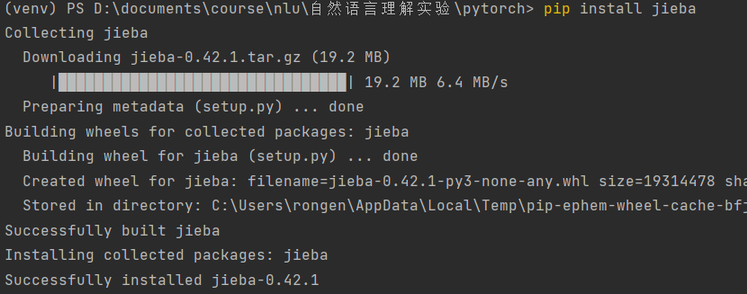
- 导入依赖库
import jieba
import pandas as pd
import numpy as np
import tensorflow as tf
from tensorflow.keras.preprocessing.sequence import pad_sequences
from sklearn.metrics import classification_report

- 数据集获取及加载
数据集采用的是在 github 上面找的相关中文数据集，将数据导入进项目文件夹中并加载。
train_data = pd.read_csv('data/train.tsv', sep='\t')
valid_data = pd.read_csv('data/dev.tsv', sep='\t')
test_data = pd.read_csv('data/test.tsv', sep='\t')
x_train, y_train = train_data.text_a.values, train_data.label.values # 训练集
x_valid, y_valid = valid_data.text_a.values, valid_data.label.values # 验证集
x_test, y_test = test_data.text_a.values, test_data.label.values # 测试集

- 构建词汇表，词汇表用于将文字映射成对应的索引 ID.
vocab = set()
cut_docs = train_data.text_a.apply(lambda x: jieba.cut(x)).values
for doc in cut_docs:
for word in doc:
if word.strip():
vocab.add(word.strip())

# 将词表写入本地vocab.txt文件
with open('data/vocab.txt', 'w') as file:
for word in vocab:
file.write(word)
file.write('\n')

- 定义相关配置参数，如词向量维度、最大填充长度等
class Config():
embedding_dim = 300 # 词向量维度 max_seq_len = 200 # 文章最大词数
vocab_file = 'data/vocab.txt' # 词汇表文件路径 config = Config()

- 定义预处理类，用于将输入文本转换成模型输入需要的 ID 矩阵
class Preprocessor():
def __init__(self, config):
self.config = config
# 初始化词和id的映射词典，预留0给padding字符，1给词表中未见过的词
token2idx = {"[PAD]": 0, "[UNK]": 1} # {word：id}
with open(config.vocab_file, 'r') as reader:
for index, line in enumerate(reader):
token = line.strip()
token2idx[token] = index+2

self.token2idx = token2idx

def transform(self, text_list):
# 文本分词，并将词转换成相应的id, 最后不同长度的文本padding长统一长度，后面补0
idx_list = [[self.token2idx.get(word.strip(), self.token2idx['[UNK]']) for word in jieba.cut(text)] for text in text_list]
idx_padding = pad_sequences(idx_list, self.config.max_seq_len, padding='post')

return idx_padding

- 定义模型类，模型类定义了模型结构搭建、训练、评估、加载离线模型、在线推理函数。
class TextCNN(object):
def __init__(self, config):
self.config = config
self.preprocessor = Preprocessor(config)
self.class_name = {0: '负面', 1: '正面'}

def build_model(self):
# 模型架构搭建
idx_input = tf.keras.layers.Input((self.config.max_seq_len,))
input_embedding = tf.keras.layers.Embedding(len(self.preprocessor.token2idx),
self.config.embedding_dim,
input_length=self.config.max_seq_len,
mask_zero=True)(idx_input)
convs = []
for kernel_size in [3, 4, 5]:
c = tf.keras.layers.Conv1D(128, kernel_size, activation='relu')(input_embedding)
c = tf.keras.layers.GlobalMaxPooling1D()(c)
convs.append(c)
fea_cnn = tf.keras.layers.Concatenate()(convs)
fea_cnn_dropout = tf.keras.layers.Dropout(rate=0.4)(fea_cnn)

fea_dense = tf.keras.layers.Dense(128, activation='relu')(fea_cnn_dropout)
output = tf.keras.layers.Dense(2, activation='softmax')(fea_dense)

model = tf.keras.Model(inputs=idx_input, outputs=output)
model.compile(loss='sparse_categorical_crossentropy',
optimizer='adam',
metrics=['accuracy'])

model.summary()

self.model = model

def fit(self, x_train, y_train, x_valid=None, y_valid=None, epochs=5, batch_size=128, callbacks=None, **kwargs):
# 训练
self.build_model()

x_train = self.preprocessor.transform(x_train)
valid_data = None
if x_valid is not None and y_valid is not None:
x_valid = self.preprocessor.transform(x_valid)
valid_data = (x_valid, y_valid)

self.model.fit(
x=x_train,
y=y_train,
validation_data= valid_data,
batch_size=batch_size,
epochs=epochs,
callbacks=callbacks,
**kwargs
)

def evaluate(self, x_test, y_test):
# 评估
x_test = self.preprocessor.transform(x_test)
y_pred_probs = self.model.predict(x_test)
y_pred = np.argmax(y_pred_probs, axis=-1)
result = classification_report(y_test, y_pred, target_names=['负面', '正面'])
print(result)

def single_predict(self, text):
# 预测
input_idx = self.preprocessor.transform([text])
predict_prob = self.model.predict(input_idx)[0]
predict_label_id = np.argmax(predict_prob)

predict_label_name = self.class_name[predict_label_id]
predict_label_prob = predict_prob[predict_label_id]

return predict_label_name, predict_label_prob

def load_model(self, ckpt_file):
self.build_model()
self.model.load_weights(ckpt_file)

- 启动训练：定义 early_stop 早停回调函数，checkpoint 保存回调函数，传入训练数据，启动训练。
# 定义early stop早停回调函数
patience = 6
early_stop = tf.keras.callbacks.EarlyStopping(monitor='val_loss', patience=patience)

# 定义checkpoint回调函数
checkpoint_prefix = './checkpoints/textcnn_imdb_ckpt'
checkpoint_callback=tf.keras.callbacks.ModelCheckpoint(
filepath=checkpoint_prefix,
save_weights_only=True,
save_best_only=True)

# 初始化模型类，启动训练
textcnn = TextCNN(config)
textcnn.fit(x_train, y_train, x_valid, y_valid, epochs=50, callbacks=[early_stop, checkpoint_callback]) # 训练

- 测试评估：评估测试集上的效果指标
textcnn.evaluate(x_test, y_test) # 测试集评估

最终的结果见第五部分。
2. 使用 PyTorch 框架
- 数据处理
def word_cut(text):
text = regex.sub(' ', text)
return [word for word in jieba.cut(text) if word.strip()]

def get_dataset(path, text_field, label_field):
text_field.tokenize = word_cut
train, dev = data.TabularDataset.splits(
path=path, format='tsv', skip_header=True,
train='train.tsv', validation='dev.tsv',
fields=[
# ('index', None),
('label', label_field),
('text', text_field)
]
)
return train, dev

- 建立的模型
class TextCNN(nn.Module):
def __init__(self, args):
super(TextCNN, self).__init__()
self.args = args

class_num = args.class_num
chanel_num = 1
filter_num = args.filter_num
filter_sizes = args.filter_sizes

vocabulary_size = args.vocabulary_size
embedding_dimension = args.embedding_dim
self.embedding = nn.Embedding(vocabulary_size, embedding_dimension)
if args.static:
self.embedding = self.embedding.from_pretrained(args.vectors, freeze=not args.non_static)
if args.multichannel:
self.embedding2 = nn.Embedding(vocabulary_size, embedding_dimension).from_pretrained(args.vectors)
chanel_num += 1
else:
self.embedding2 = None
self.convs = nn.ModuleList(
[nn.Conv2d(chanel_num, filter_num, (size, embedding_dimension)) for size in filter_sizes])
self.dropout = nn.Dropout(args.dropout)
self.fc = nn.Linear(len(filter_sizes) * filter_num, class_num)

def forward(self, x):
if self.embedding2:
x = torch.stack([self.embedding(x), self.embedding2(x)], dim=1)
else:
x = self.embedding(x)
x = x.unsqueeze(1)
x = [F.relu(conv(x)).squeeze(3) for conv in self.convs]
x = [F.max_pool1d(item, item.size(2)).squeeze(2) for item in x]
x = torch.cat(x, 1)
x = self.dropout(x)
logits = self.fc(x)
return logits

- 训练
def train(train_iter, dev_iter, model, args):
if args.cuda:
model.cuda()
optimizer = torch.optim.Adam(model.parameters(), lr=args.lr)
steps = 0
best_acc = 0
last_step = 0
model.train()
for epoch in range(1, args.epochs + 1):
for batch in train_iter:
feature, target = batch.text, batch.label

with torch.no_grad():
feature.t_(), target.sub_(1)
if args.cuda:
feature, target = feature.cuda(), target.cuda()
optimizer.zero_grad()
logits = model(feature)
loss = F.cross_entropy(logits, target)
loss.backward()
optimizer.step()
steps += 1
if steps % args.log_interval == 0:
corrects = (torch.max(logits, 1)[1].view(target.size()).data == target.data).sum()
train_acc = 100.0 * corrects / batch.batch_size
sys.stdout.write(
'\rBatch[{}] - loss: {:.6f} acc: {:.4f}%({}/{})'.format(steps,
loss.item(),
train_acc,
corrects,
batch.batch_size))
if steps % args.test_interval == 0:
dev_acc = eval(dev_iter, model, args)
if dev_acc > best_acc:
best_acc = dev_acc
last_step = steps
if args.save_best:
print('Saving best model, acc: {:.4f}%\n'.format(best_acc))
save(model, args.save_dir, 'best', steps)
else:
if steps - last_step >= args.early_stopping:
print('\nearly stop by {} steps, acc: {:.4f}%'.format(args.early_stopping, best_acc))
raise KeyboardInterrupt

def eval(data_iter, model, args):
model.eval()
corrects, avg_loss = 0, 0
prob_all = []
label_all = []
for batch in data_iter:
feature, target = batch.text, batch.label

with torch.no_grad():
feature.t_(), target.sub_(1)
if args.cuda:
feature, target = feature.cuda(), target.cuda()
logits = model(feature)
loss = F.cross_entropy(logits, target)
avg_loss += loss.item()
prob = logits.cpu().detach().numpy()
prob_all.extend(np.argmax(prob, axis=1)) # 求每一行的最大值索引
label_all.extend(target.cpu().detach().numpy())
corrects += (torch.max(logits, 1)
[1].view(target.size()).data == target.data).sum()
size = len(data_iter.dataset)
avg_loss /= size
accuracy = 100.0 * corrects / size
f1=f1_score(label_all,prob_all)
print('\nEvaluation - loss: {:.6f} acc: {:.4f}%({}/{}) F1-Score:{:.4f} precision-Score:{:.4f} recall:{:.4f} roc:{:.4f}\n'.format(avg_loss,
accuracy,
corrects,
size,f1_score(label_all,prob_all),
precision_score(label_all,prob_all), recall_score(label_all,prob_all),
roc_auc_score(label_all,prob_all)))
return accuracy

def save(model, save_dir, save_prefix, steps):
if not os.path.isdir(save_dir):
os.makedirs(save_dir)
save_prefix = os.path.join(save_dir, save_prefix)
save_path = '{}_steps_{}.pt'.format(save_prefix, steps)
torch.save(model.state_dict(), save_path)

详细代码可见文件夹 pytorch
- 实验结果
- TensorFlow 框架实验结果
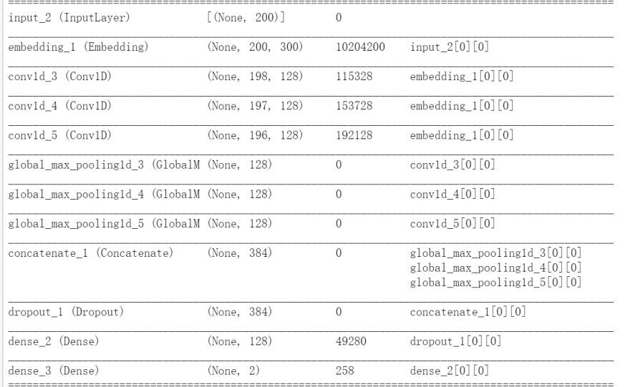
- PyTorch 框架实验结果
TextCNN
TextRNN
 | Acc | F1-score | recall | precision | auc
TextCNN | 0.9394 | 0.9400 | 0.9311 | 0.9492 | 0.9396
TextRNN | 0.9401 | 0.9417 | 0.9482 | 0.9353 | 0.9400

- 实验分工
学号 | 姓名 | 负责任务
SA21011147 | 许荣仁 | Pytorch 实验代码、TF 实验代码
SA21011074 | 齐瑜鹏 | 报告编写、数据集、环境配置

- 实验总结
在本次实验中学习了如何使用 PyTorch 和 Tensorflow 搭建用于文本分类的 CNN 模型，也了解了文本分类任务的基本流程，理解了卷积神经网络在文本任务中的使用方法。通过实验也加深了对 CNN 网络的理解，同时提升了代码实践能力。

