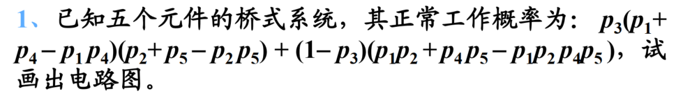
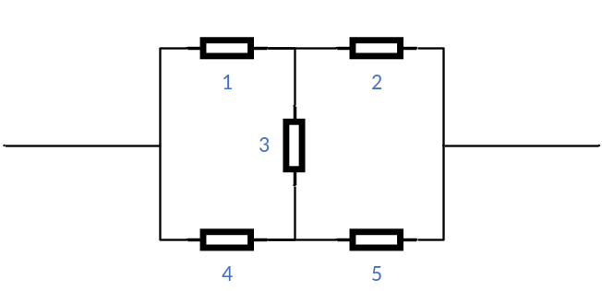

- A：某人感染病毒，B：测试为阳性， P(A|B)即为所求
$$P\left(A | B\right)=\frac{P\left(AB\right)}{P\left(B\right)}=\frac{P\left(A\right)P\left(B | A\right)}{P\left(A\right)P\left(B | A\right)+P\left(\overline{A}\right)P\left(B | \overline{A}\right)}=\frac{0.01*0.999}{0.01*0.999+0.99*0.001}≈90.98\%$$
- A：某人感染病毒，B：第一次测试为阳性，C：第二次测试阳性，$P(A|BC)$即为所求
$$P\left(A | BC\right)=\frac{P\left(ABC\right)}{P\left(BC\right)}=\frac{P\left(A\right)\left(B | A\right)P\left(C | A\right)}{P\left(\overline{A}BC\right)+P(ABC)}=\frac{P\left(A\right)\left(B | A\right)P\left(C | A\right)}{P\left(\overline{A}\right)\left(B | \overline{A}\right)P\left(C | \overline{A}\right)+P\left(\overline{A}\right)\left(B | \overline{A}\right)P\left(C | \overline{A}\right)}=\frac{0.01*0.999*0.999}{0.99*0.001*0.001+0.01*0.999*0.999}≈99.99\%$$
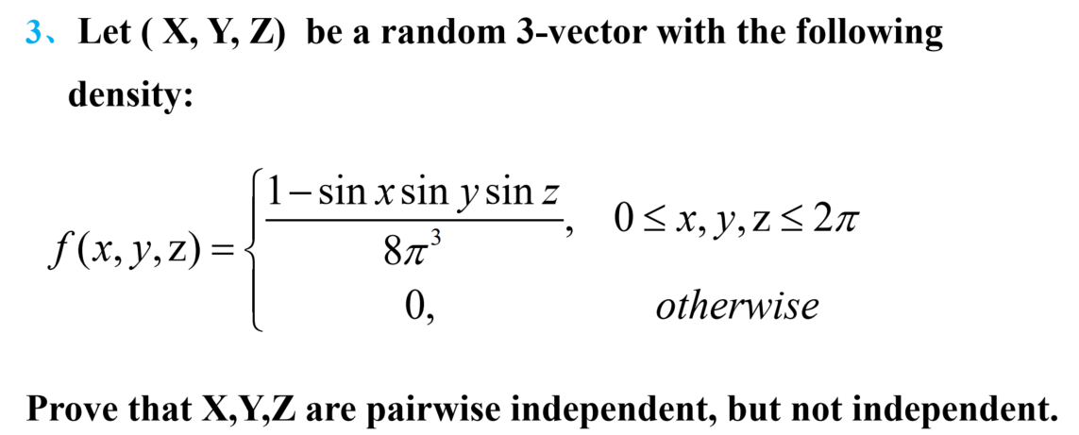
- 两两独立：
$$f_{x}\left(x\right)=\int_{-∞}^{+∞}{\int_{-∞}^{+∞}{f\left(x,y,z\right)dydz}}$$
$$=\int_{0}^{2π}{\int_{0}^{2π}{\frac{1-\sin{x}\sin{y}\sin{z}}{8π^{3}}}dydz}$$
$$=\frac{1}{8π^{3}}\int_{0}^{2π}{\int_{0}^{2π}{\left(1-\sin{x\sin{y }}\right)dydz}}=\frac{1}{8π^{3}}(4π^{2}-\sin{x}\int_{0}^{2π}{\int_{0}^{2π}{\sin{y}\sin{z}dydz}})=\frac{1}{8π^{3}}\left(4π^{2}-\sin{x}\int_{0}^{2π}{\sin{y}dy}\int_{0}^{2π}{\sin{z}dz}\right)=\frac{1}{8π^{3}}\left(4π^{2}-0\right)$$
$$=\frac{1}{2π} , (0≤x≤2π)$$
同样可得，$f_{y}\left(y\right)=\frac{1}{2π}$
$$f_{x,y}\left(x,y\right)=\int_{0}^{2π}{\frac{1-\sin{x}\sin{y}\sin{z}}{8π^{3}}dz}=\frac{1}{8π^{3}}\left(2π-\sin{x}\sin{y}\int_{0}^{2π}{\sin{z}dz}\right)$$
$$=\frac{1}{4π^{2}}, (0≤x,y≤2π)$$
所以$f_{x,y}\left(x,y\right)=f_{x}\left(x\right)*f_{y}(y)$，所以变量XY独立，同样可证，XZ独立，YZ独立，即XYZ两两独立。
- 不相互独立：
$\left(x,y,z\right)=\left(\frac{π}{2},\frac{π}{2},\frac{π}{2}\right)$时，有$f\left(x,y,z\right)=0, f_{X}\left(x\right)*f_{y}\left(y\right)*f_{z}\left(z\right)=\frac{1}{2π}*\frac{1}{2π}*\frac{1}{2π}=\frac{1}{8π^{3}}$，不相等，所以XYZ不独立

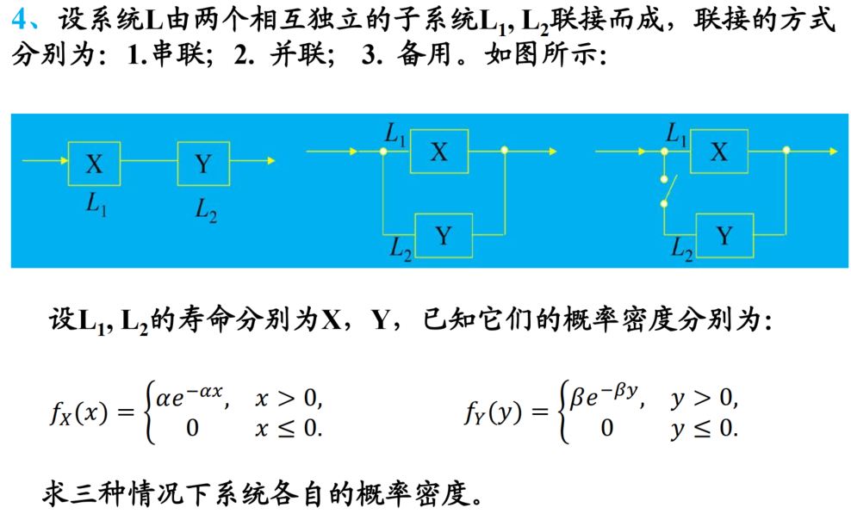
- 串联，$L_{1}L_{2}$要同时正常工作，$Z=\min\left(X,Y\right)$
$$F_{Z}\left(z\right)=P\left\{Z≤z\right\}=P\left\{\min\left(X,Y\right)≤z\right\}=P\left\{X≤z\right\}+P\left\{Y≤z\right\}-P\left\{X≤z,Y≤z\right\}$$
$$=F_{X}\left(z\right)+F_{Y}\left(z\right)-F_{X}\left(z\right)F_{Y}\left(z\right)$$
$z>0$时，$f_{Z}\left(z\right)=F_{Z}^{'}\left(z\right)=αe^{-αz}+βe^{-βz}-\left(1-e^{-αz}\right)βe^{-βz}-\left(1-e^{-βz}\right)αe^{-αz}$
$$=\left(α+β\right)e^{-\left(α+β\right)z}, z>0$$
$z≤0$时，$f_{Z}\left(z\right)=0$,
所以$f_{Z}\left(z\right)=\left\{\begin{aligned}\left(α+β\right)e^{-\left(α+β\right)z}, z>0 \\ 0, z≤0\end{aligned}\right.$
- 并联，$L_{1}L_{2}$至少有一个正常工作即可，$Z=\max\left(X,Y\right)$
$$F_{Z}\left(z\right)=P\left\{Z≤z\right\}=P\left\{\max\left(X,Y\right)≤z\right\}=P\left\{X≤z,Y≤z\right\}$$
$$=F_{X}\left(z\right)F_{Y}\left(z\right)$$
$z>0$时，$f_{Z}\left(z\right)=F_{Z}^{'}\left(z\right)=\left(1-e^{-αz}\right)βe^{-βz}+\left(1-e^{-βz}\right)αe^{-αz}$
$$=αe^{-αz}+βe^{-βz}-\left(α+β\right)e^{-\left(α+β\right)z}, z>0$$
$z≤0$时，$f_{Z}\left(z\right)=0$,
所以$f_{Z}\left(z\right)=\left\{\begin{aligned}αe^{-αz}+βe^{-βz}-\left(α+β\right)e^{-\left(α+β\right)z}, z>0 \\ 0, z≤0\end{aligned}\right.$

- 备用，$Z=X+Y$
$f_{Z}\left(z\right)=\int_{-∞}^{∞}{f_{X}\left(x\right)f_{Y}\left(z-x\right)dx}$.
$z<0$时，$f_{Z}\left(z\right)=0$
$z≥0$时，$f_{Z}\left(z\right)=\int_{0}^{z}{αe^{-αx}βe^{-β(z-x)}dx=\frac{αβ(e^{-βz}-e^{-αz})}{α-β}}$
所以$f_{Z}\left(z\right)=\left\{\begin{aligned}\frac{αβ(e^{-βz}-e^{-αz})}{α-β}, z>0 \\ 0, z≤0\end{aligned}\right.$

因为X，Y相互独立，均服从正态分布，所以Z=2X-Y+2也服从正态分布
$$E\left(Z\right)=E\left(2X-Y+2\right)=E\left(2X\right)-E\left(Y\right)+2=2E\left(X\right)-E\left(Y\right)+2=2-5+2=-1$$
$$D\left(Z\right)=D\left(2X-Y+2\right)=D\left(2X-Y\right)=D\left(2X\right)+D\left(Y\right)=4D\left(X\right)+D\left(Y\right)=8+9=17$$
所以$Z\sim N\left(-1,17\right)$
$$f\left(z\right)=\frac{1}{\sqrt{2π}\sqrt{17}}\exp\left(-\frac{{\left(z+1\right)}^{2}}{2*17}\right)=\frac{1}{\sqrt{34π}}exp⁡(-\frac{{\left(z+1\right)}^{2}}{34})$$

$$f\left(z\right)=\left\{\begin{aligned}\frac{1}{2π}, 0≤z≤2π \\ 0, z<0 or z>2π\end{aligned}\right.$$
$$E\left(X\right)=E\left(\sin{Z}\right)=\frac{1}{2π}\int_{0}^{2π}{\sin{z}dz}=0$$
$$E\left(Y\right)=E\left(\cos{Z}\right)=\frac{1}{2π}\int_{0}^{2π}{\cos{z}dz}=0$$
$$E\left(XY\right)=E\left(\sin{Z}\cos{Z}\right)=\frac{1}{2π}\int_{0}^{2π}{\sin{z}\cos{z}dz}=\frac{1}{2π}\int_{0}^{2π}{\frac{1}{2}\sin{2z}dz}= 0$$
$$Cov\left(X,Y\right)=E\left(XY\right)-E\left(X\right)E\left(Y\right)=0$$
所以 $ρ_{X,Y}=0$
X与Y不相关
因为$X^{2}+Y^{2}=1, (0≤X,Y≤2π)$，所以XY不相互独立

第$i$个终端工作记为$X_{i}=1$，不工作为$X_{i}=0$
$$P\left(X_{i}=1\right)=0.1,$$
又记$Y=X_{1}+X_{2}+…+X_{100}$，则$E\left(Y\right)=10$, $Var\left(Y\right)=9$，由此得：
$$P\left\{Y≤12\right\}≈Φ\left(\frac{12+0.5-10}{\sqrt{9}}\right)=0.7967$$
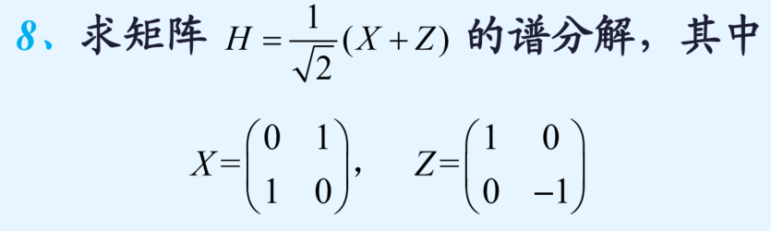
$H=\frac{1}{\sqrt{2}}\left(\begin{matrix}1 & 1 \\ 1 & -1\end{matrix}\right)=\frac{1}{\sqrt{2}}A$，设矩阵$H$特征值为$λ$，特征向量为$α$，有$Hα=λα$，特征方程为：$\left|λI-H\right|=0$，$\left|\begin{matrix}λ-\frac{1}{\sqrt{2}} & -\frac{1}{\sqrt{2}} \\ -\frac{1}{\sqrt{2}} & λ+\frac{1}{\sqrt{2}}\end{matrix}\right|=0$，解得：
$λ_{1}=1, λ_{2}=-1$.
$λ_{1}=1$时，特征向量为$α_{1}=\left[\begin{matrix}1 \\ \sqrt{2}-1\end{matrix}\right]$，$λ_{2}=-1$时，对应特征向量为$α_{2}=\left[\begin{matrix}-\sqrt{2}+1 \\ 1\end{matrix}\right]$
$α_{1} α_{2}$正交，单位化得$ξ_{1}=\left[\begin{matrix}\frac{1}{\sqrt{4-2\sqrt{2}}} \\ \frac{\sqrt{2}-1}{\sqrt{4-2\sqrt{2}}}\end{matrix}\right],ξ_{2}=\left[\begin{matrix}\frac{-\sqrt{2}+1}{\sqrt{4-2\sqrt{2}}} \\ \frac{1}{\sqrt{4-2\sqrt{2}}}\end{matrix}\right]$
令$P=\left[ξ_{1}, ξ_{2}\right]=\left[\begin{matrix}\frac{1}{\sqrt{4-2\sqrt{2}}} & \frac{-\sqrt{2}+1}{\sqrt{4-2\sqrt{2}}} \\ \frac{\sqrt{2}-1}{\sqrt{4-2\sqrt{2}}} & \frac{1}{\sqrt{4-2\sqrt{2}}}\end{matrix}\right]$，则$H=P\left[\begin{matrix}1 & \\ & -1\end{matrix}\right]P^{-1}$
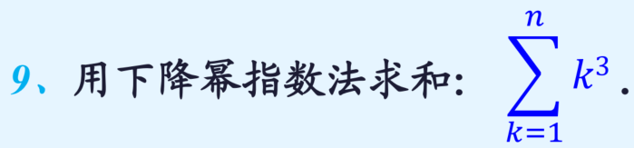
因为$x^{3}=x^{\underline{3}}+3x^{\underline{2}}+x^{\underline{1}}, 0^{3}=0$，故
$$\sum_{k=1}^{n}{k^{3}}=\sum_{k=0}^{n}{k^{3}}=\sum_{k=0}^{n+1}{k^{3}δk}=\sum_{k=0}^{n+1}{\left(k^{\underline{3}}+3k^{\underline{2}}+k^{\underline{1}}\right)δk}=\left(\frac{k^{\underline{4}}}{4}+3*\frac{k^{\underline{3}}}{3}+\frac{k^{\underline{2}}}{2}\right)\left|{n+1 \atop 0}\right.=\frac{{\left(n+1\right)}^{\underline{4}}}{4}+{\left(n+1\right)}^{\underline{3}}+\frac{{\left(n+1\right)}^{\underline{2}}}{2}=\frac{\left(n+1\right)n\left(n-1\right)\left(n-2\right)}{4}+\left(n+1\right)n\left(n-1\right)+\frac{\left(n+1\right)n}{2}$$
$$=\frac{n^{2}{\left(n+1\right)}^{2}}{4}$$

