2018
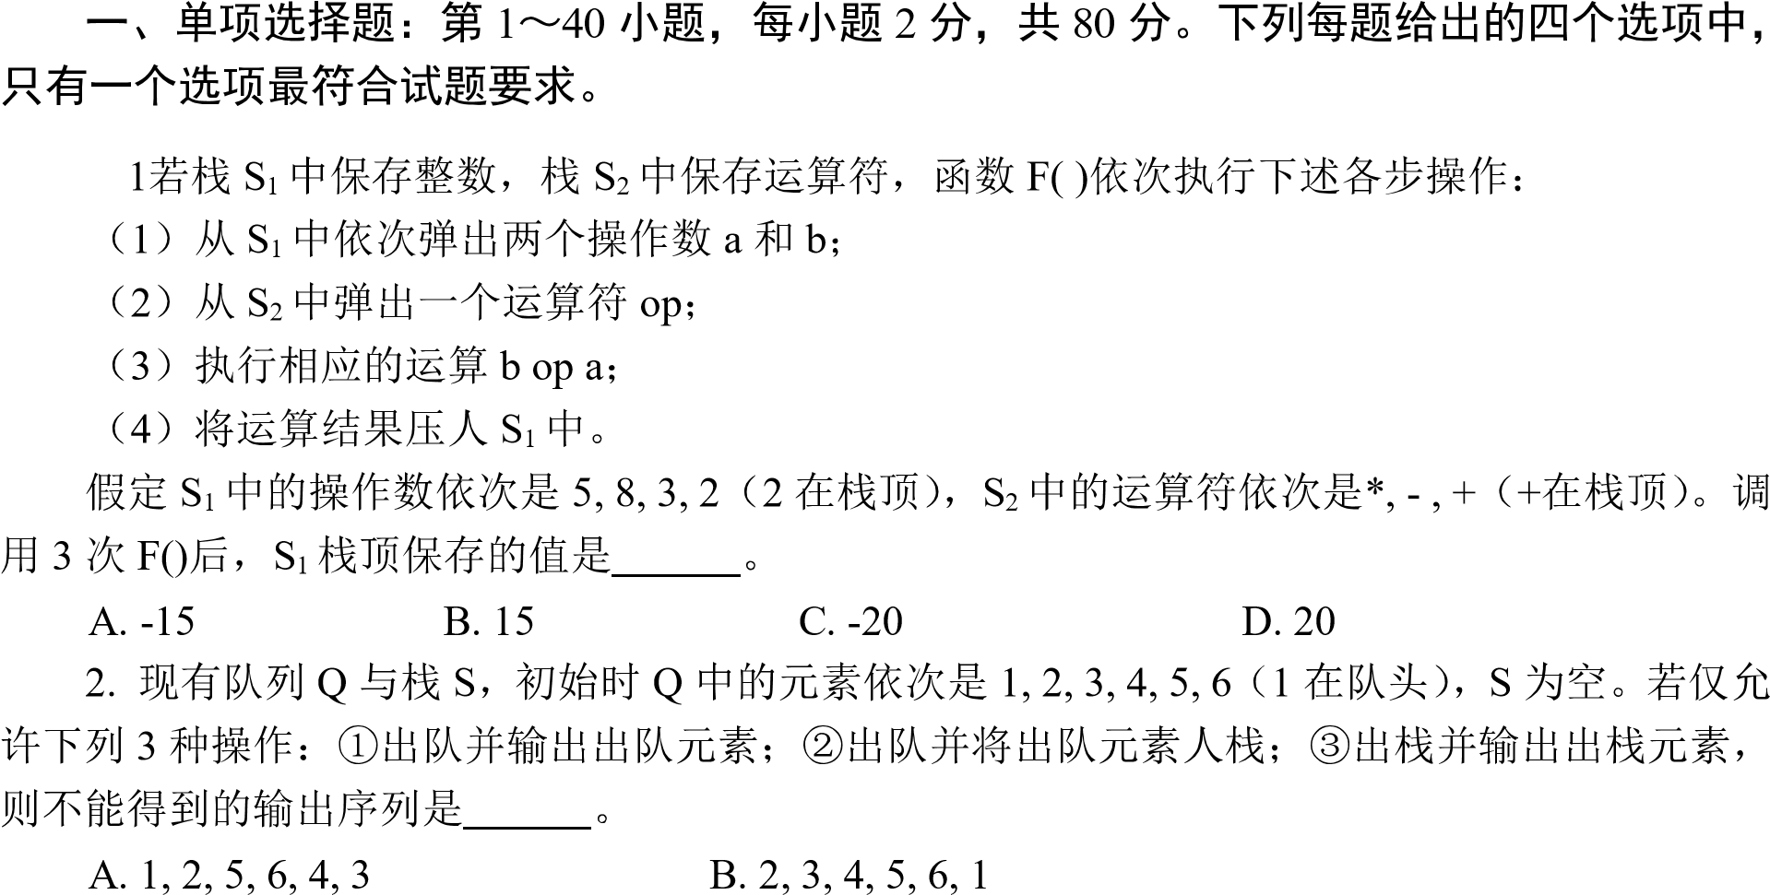
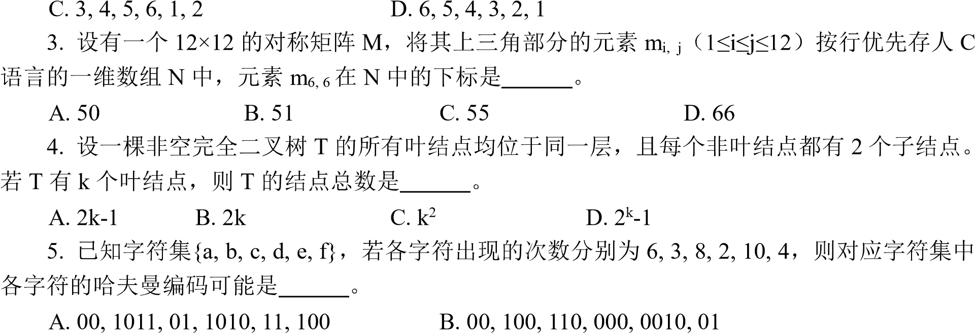
- 10, 1011, 11, 0011, 00, 010 D. 0011, 10, 11, 0010, 01, 000
6.
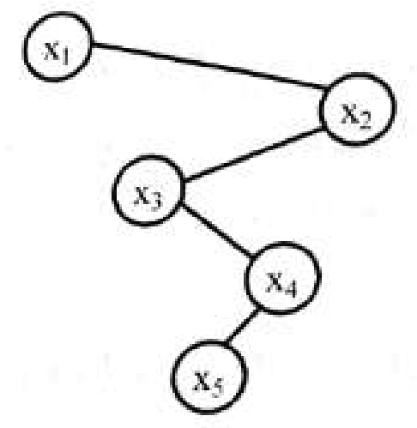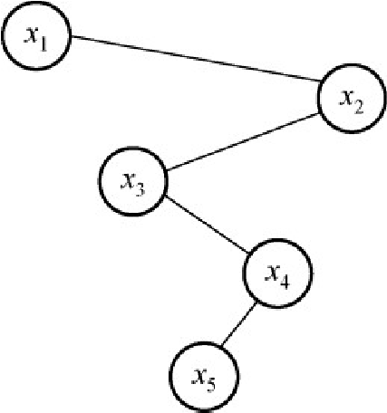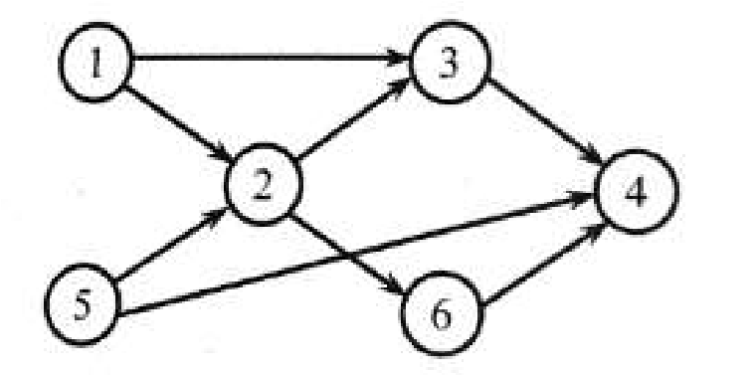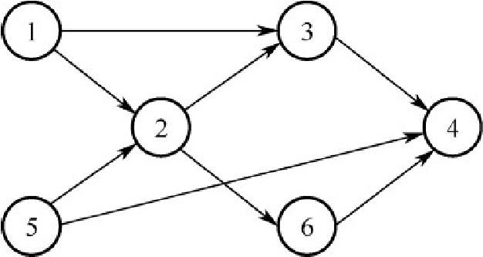
A. x
1
<
x
2
<
x
5
B. x
1
<
x
4
x
<
5
C. x
3
<
x
5
<
x
4
D. x
4
x
<
3
<
x
5
7.
A. 1, 5, 2, 3, 6, 4
B. 5, 1, 2, 6, 3, 4
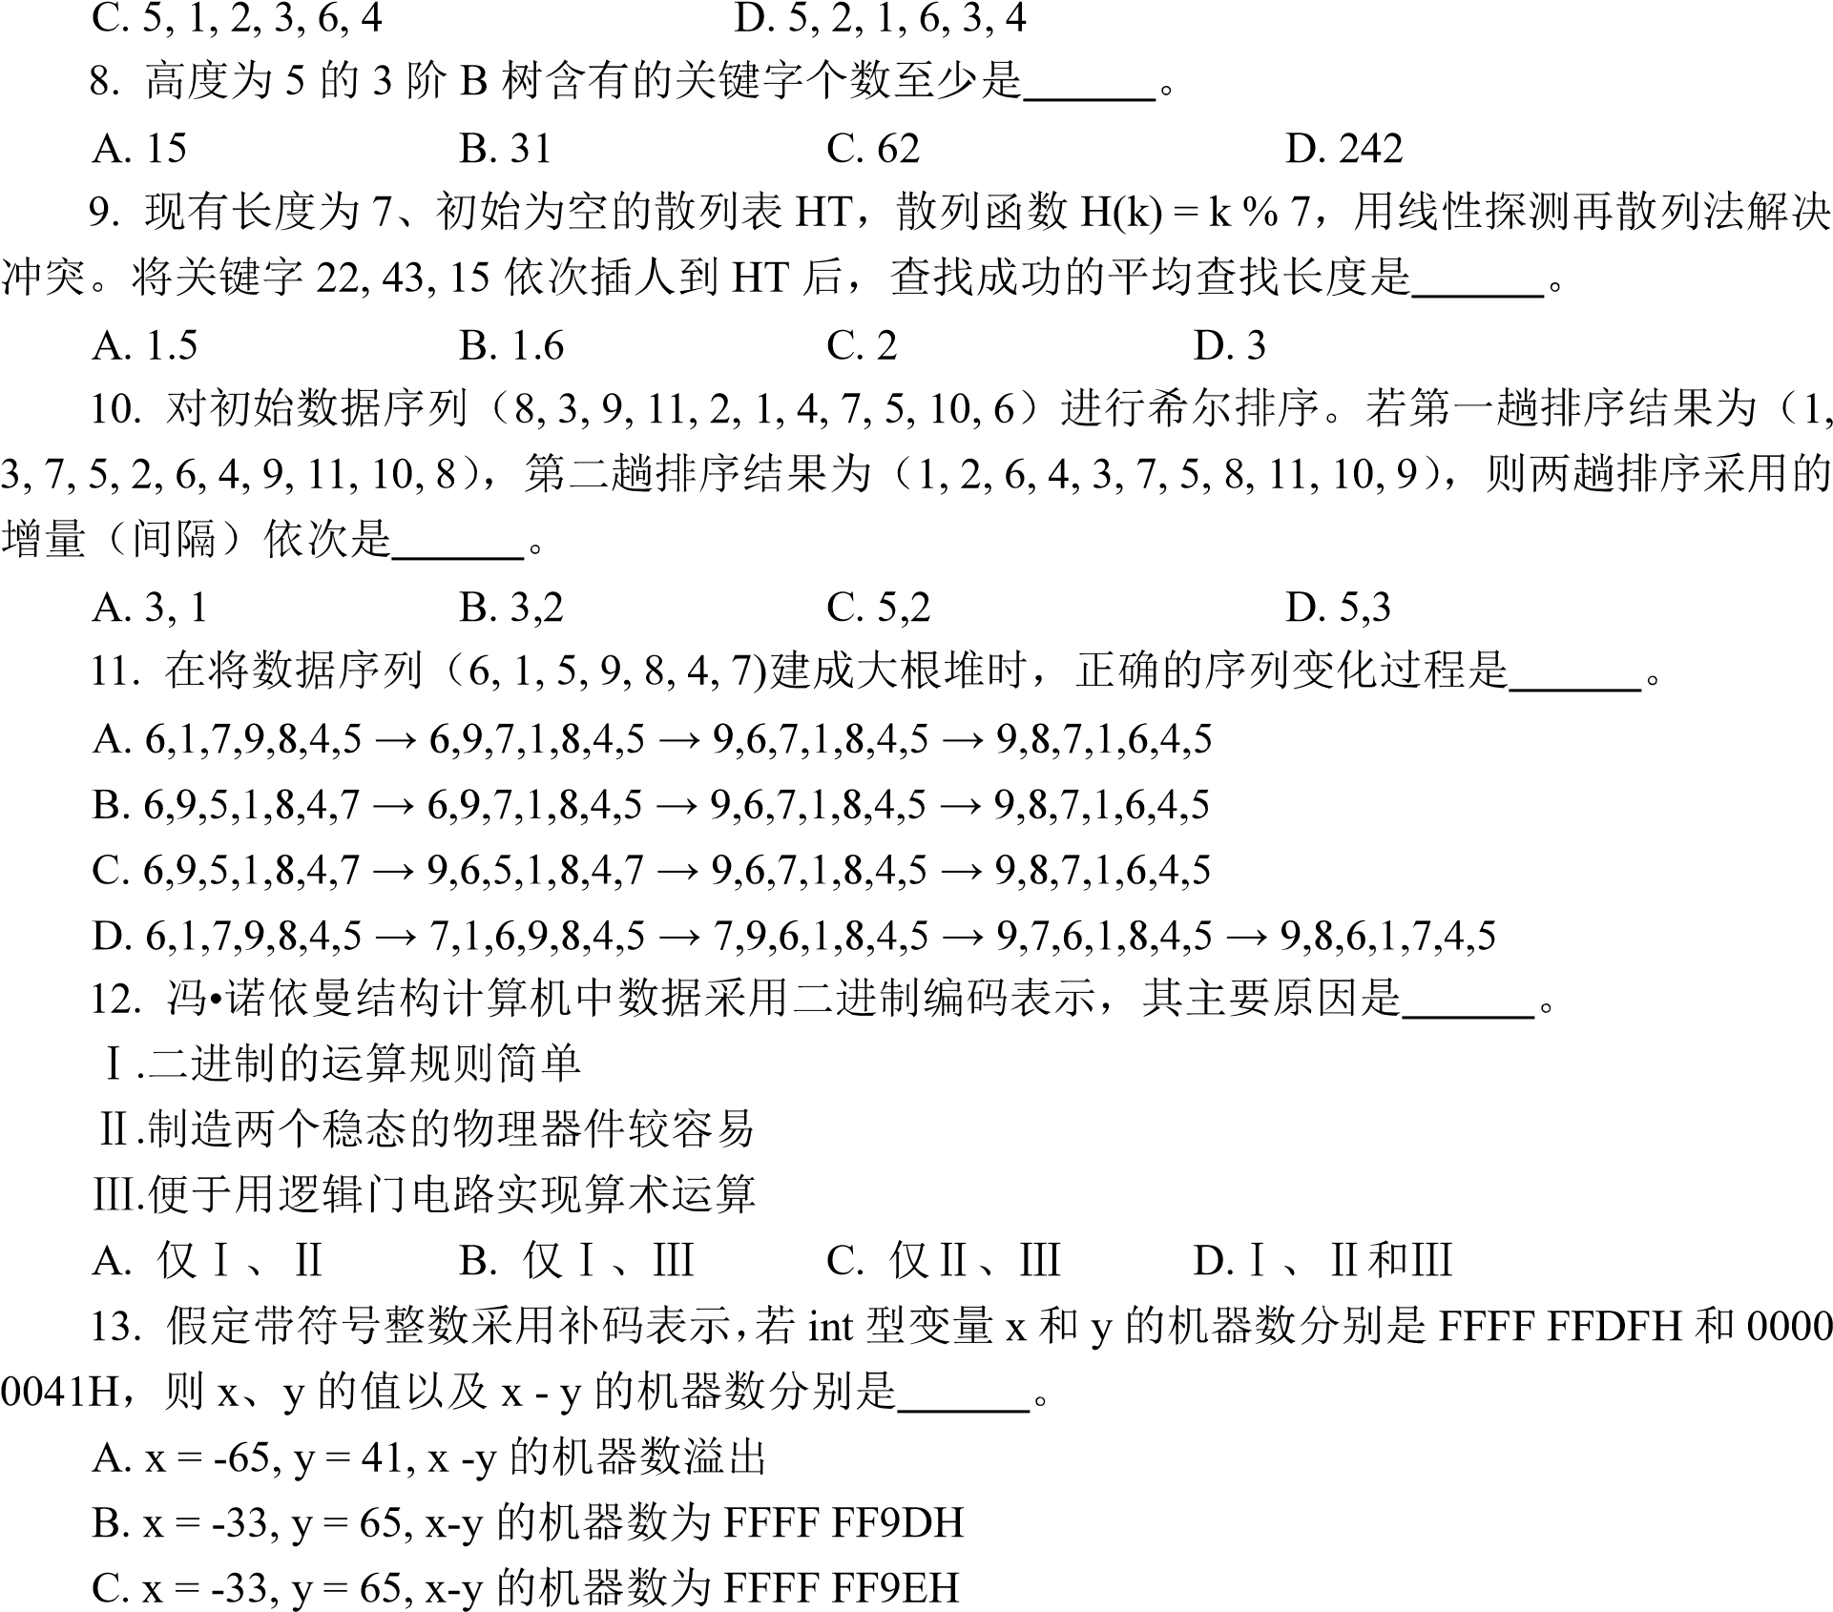
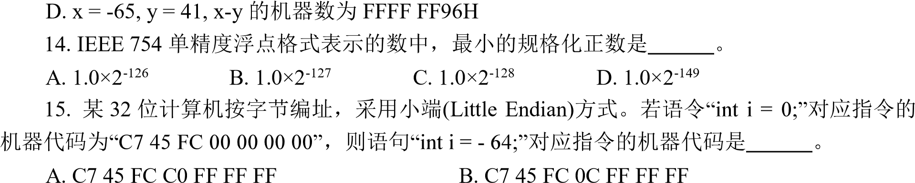
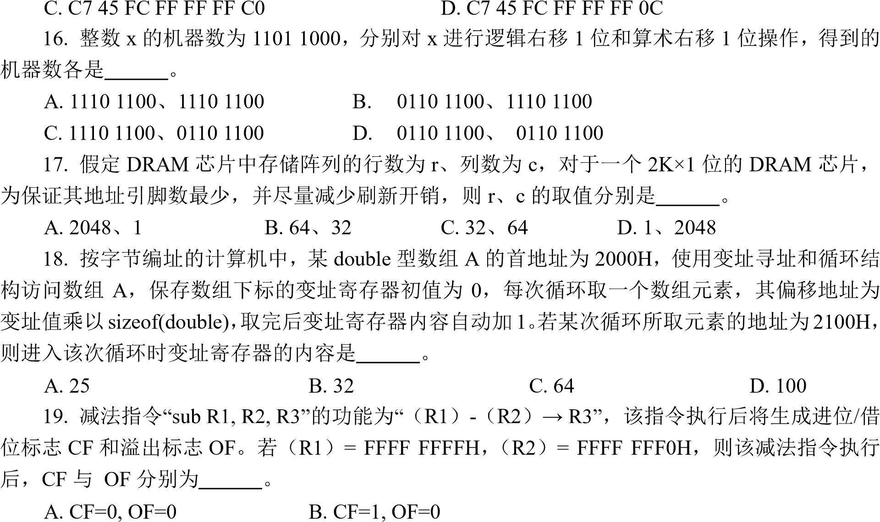
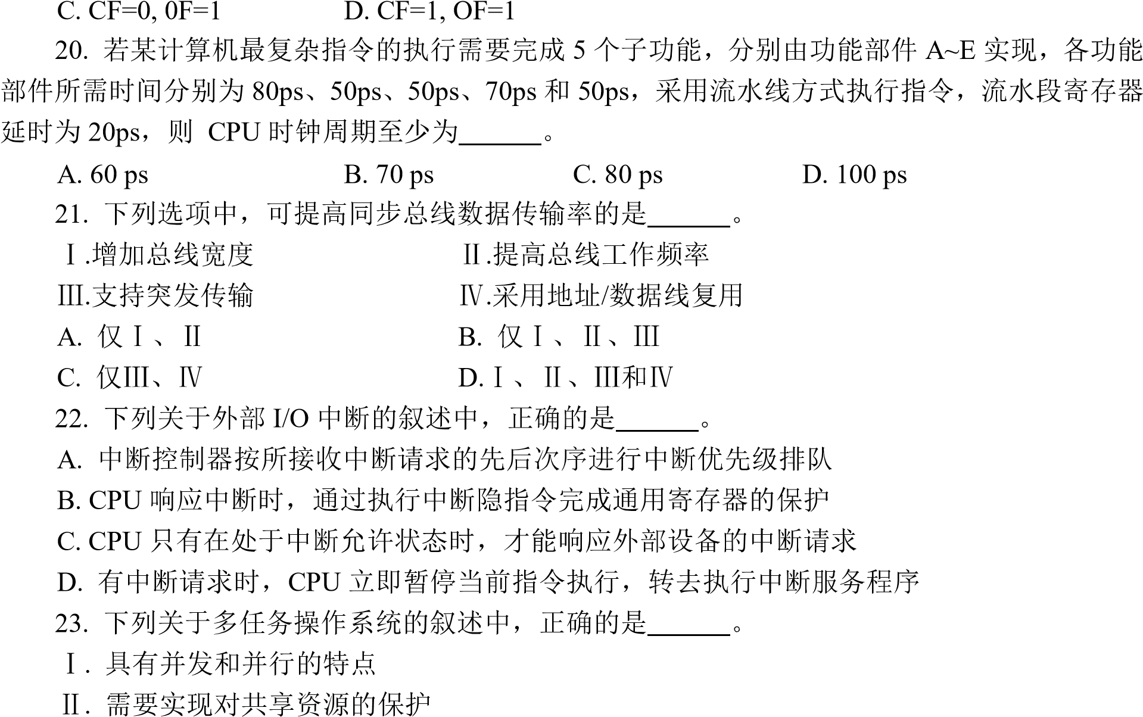
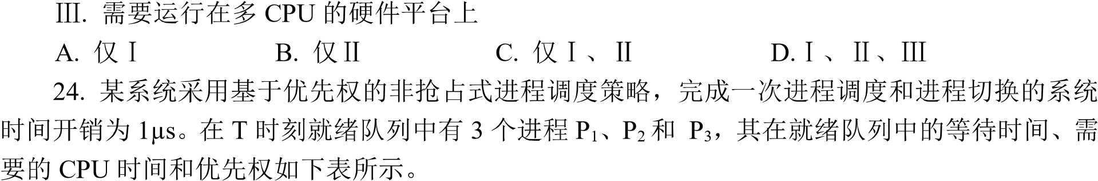
 |  | CPU
P₁ | 30µs | 12µs | 10
P₂ | 15µs | 24µs | 30
P₃ | 18µs | 36µs | 20
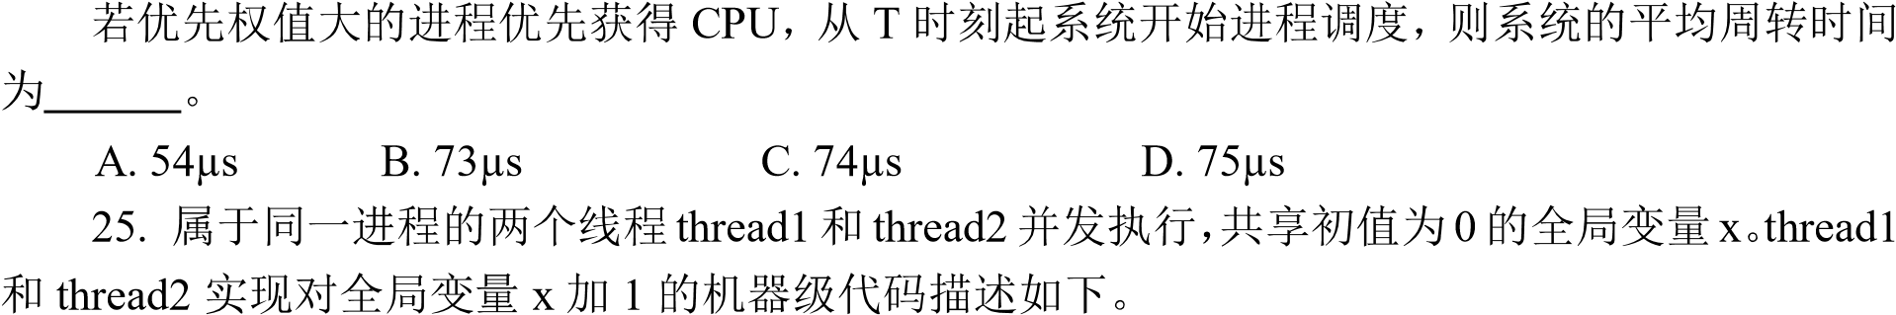
 | thread1 |  | thread2
mov R1, x inc R1 mov x, R1 | //  x  R1  R1  //  // | mov R2, x inc R2 mov x, R2 | //  x  R2  R2  //  //
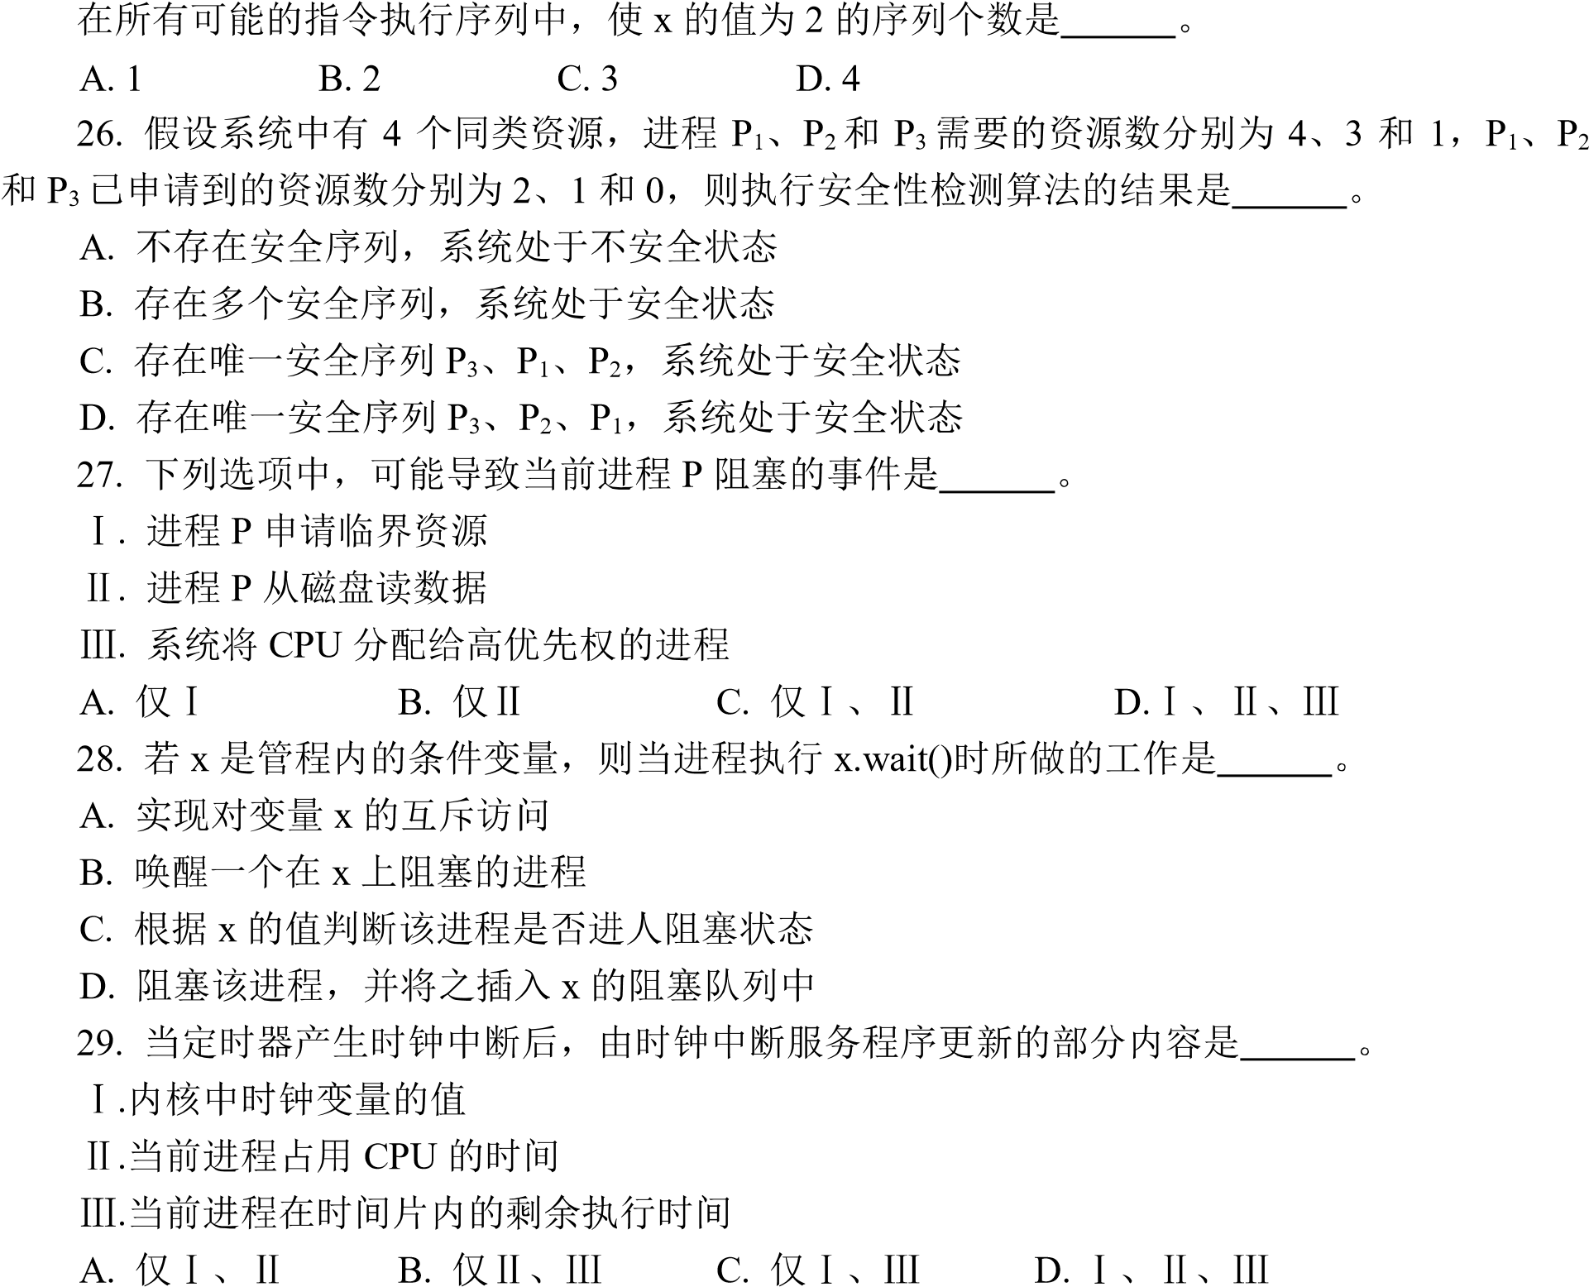
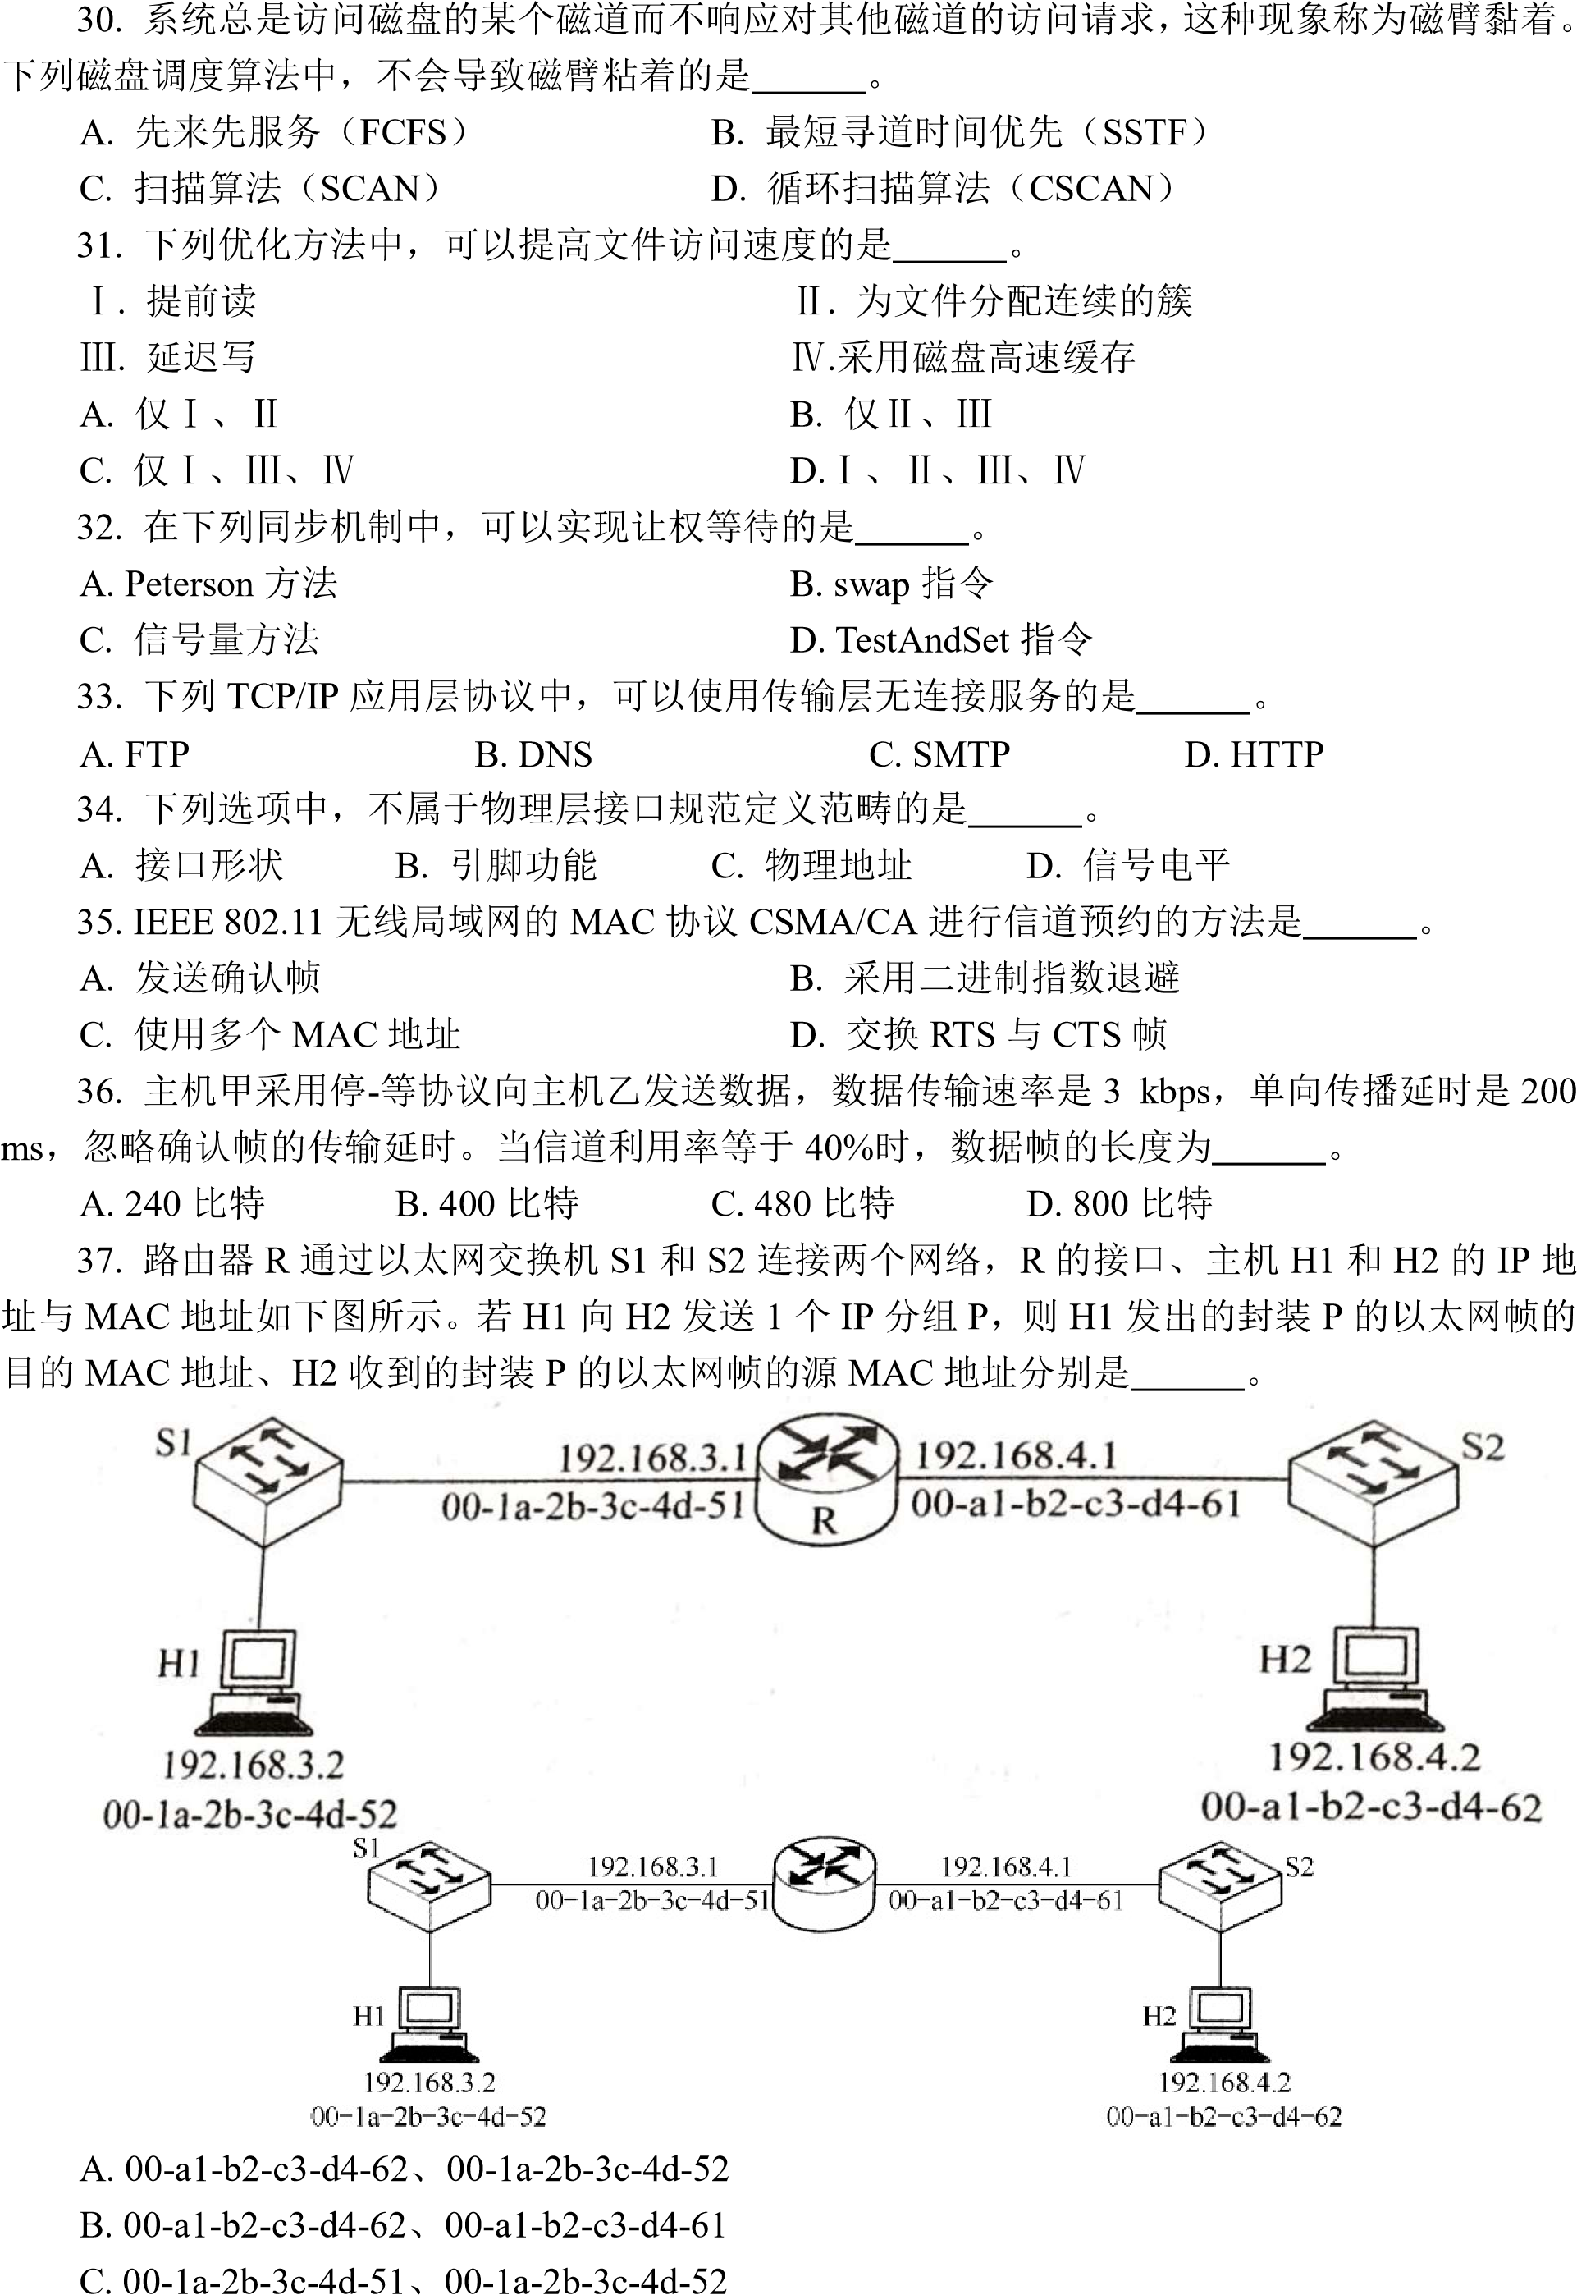
- 00-1a-2b-3c-4d-51 00-a1-b2-c3-d4-61
38.
35.230.40.0/21

A. 35.230.0.0/19 B. 35.230.0.0/20
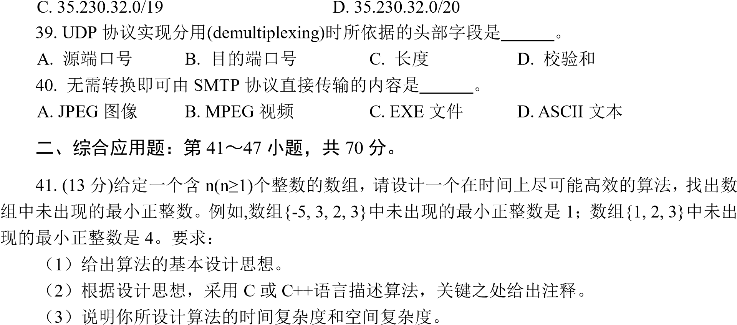
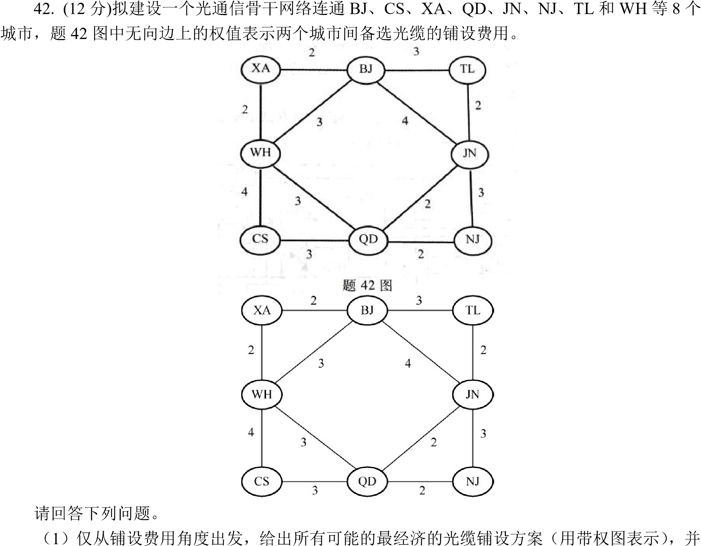
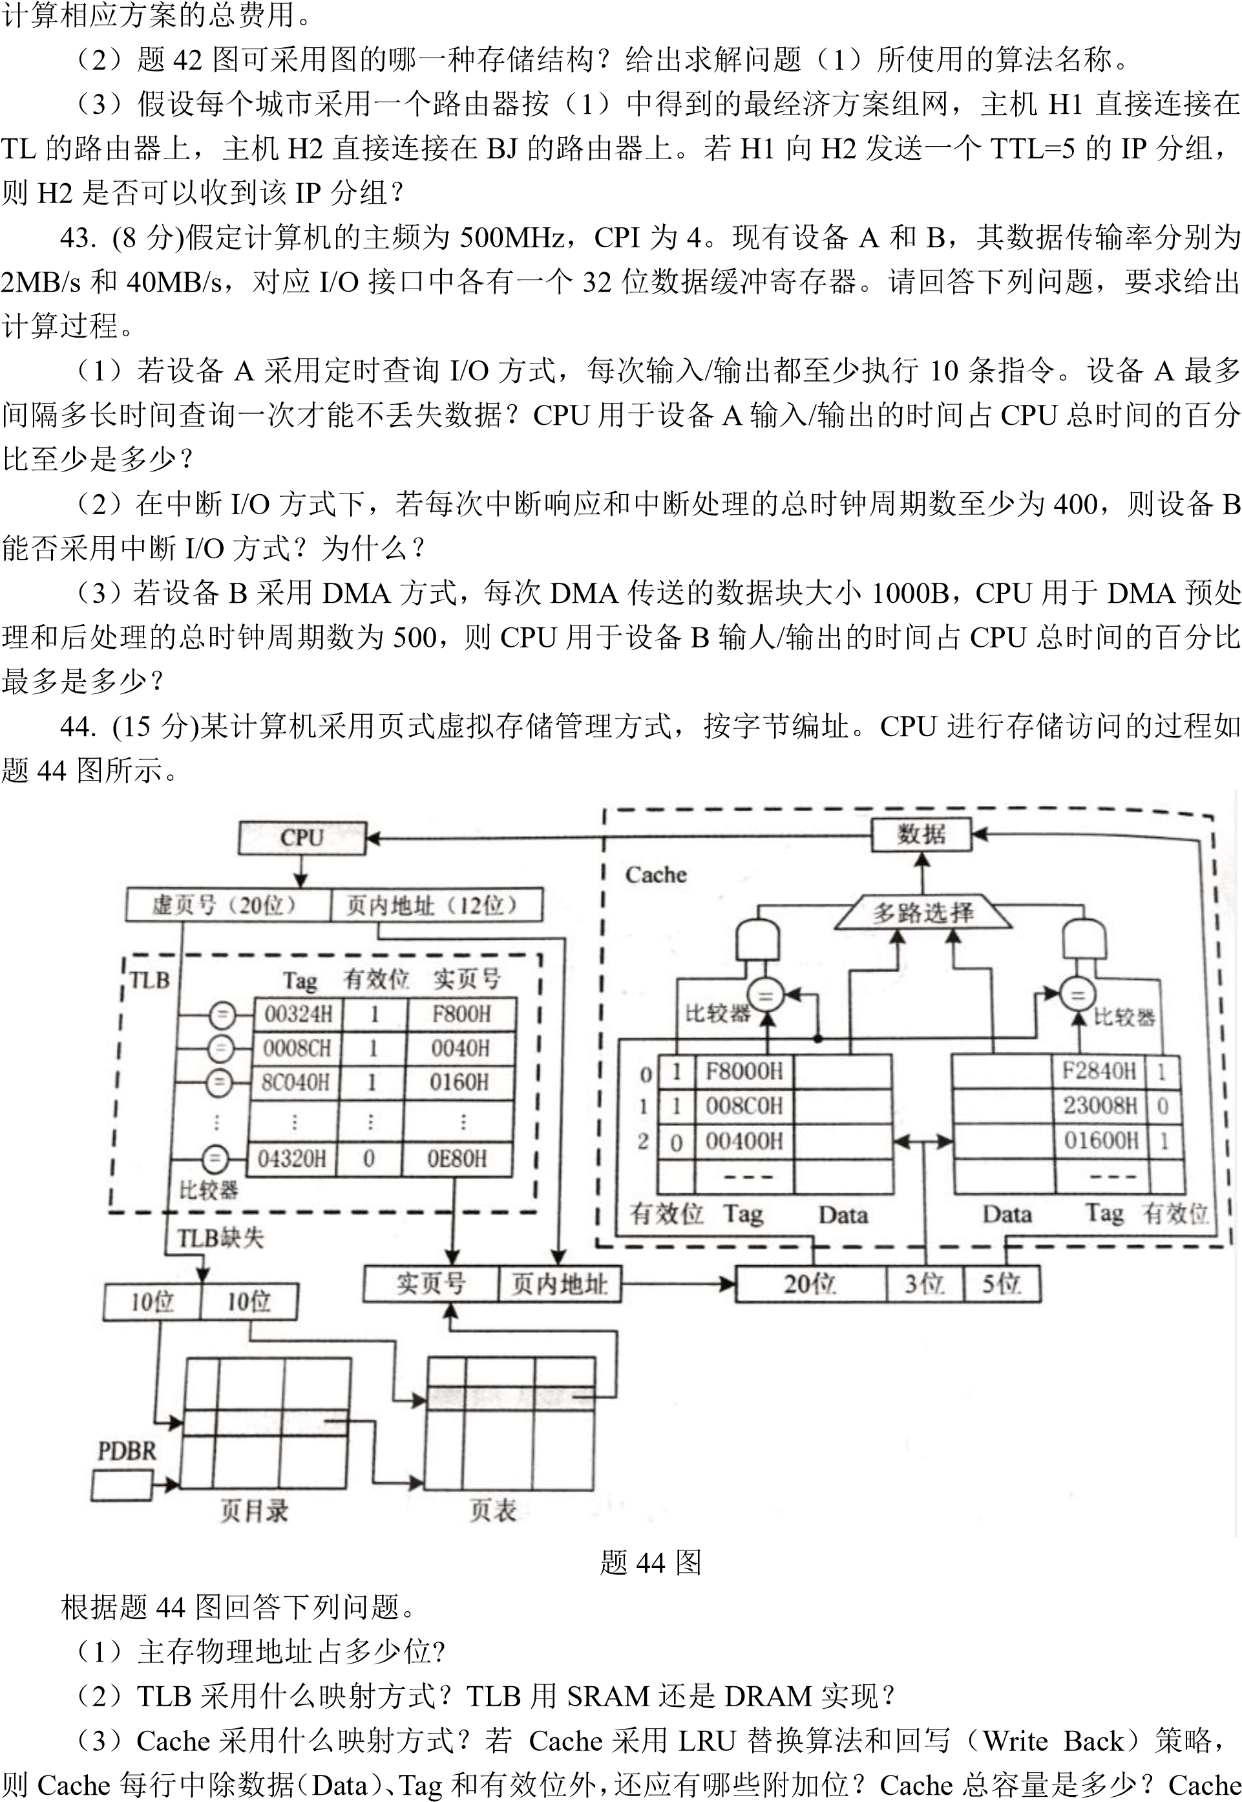
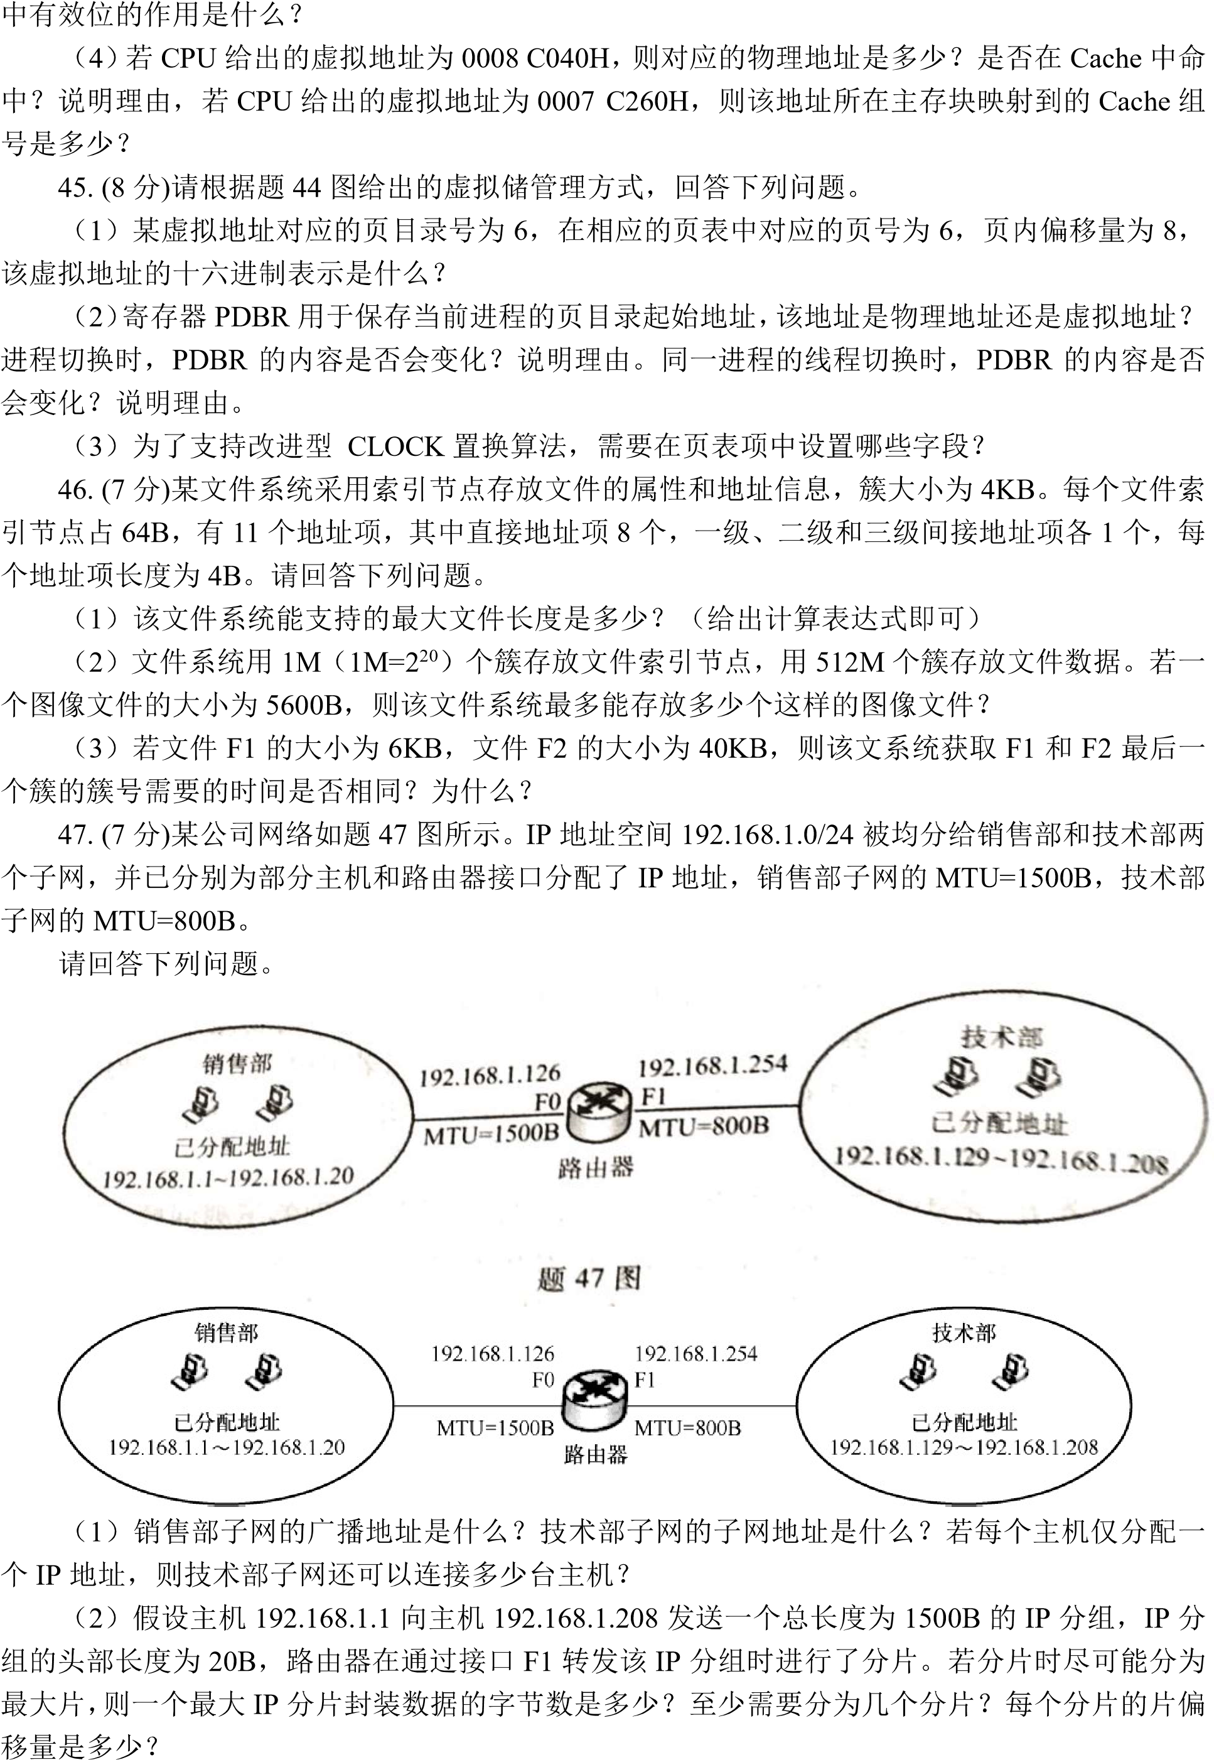
2018
