Getting to know new people is tiring

digital products， technology
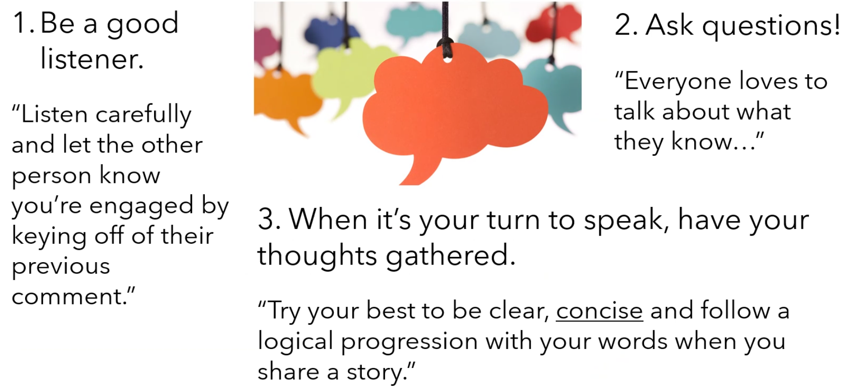
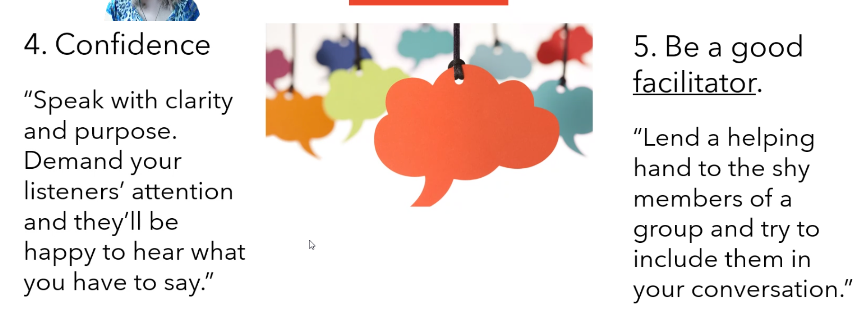
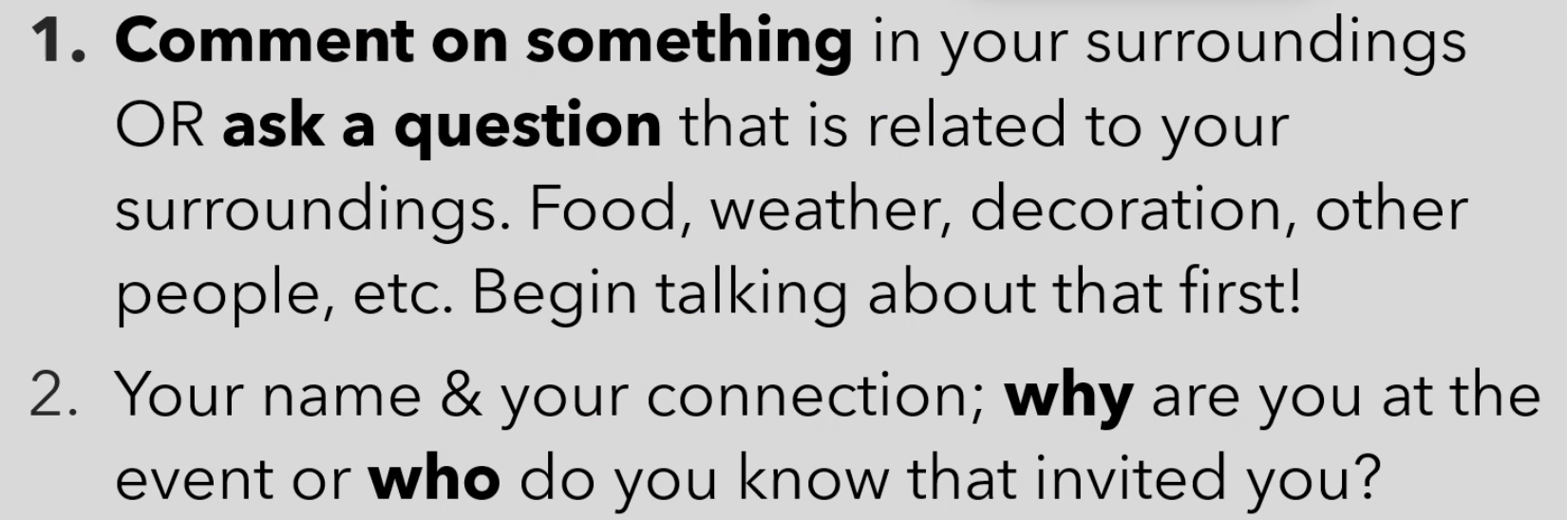
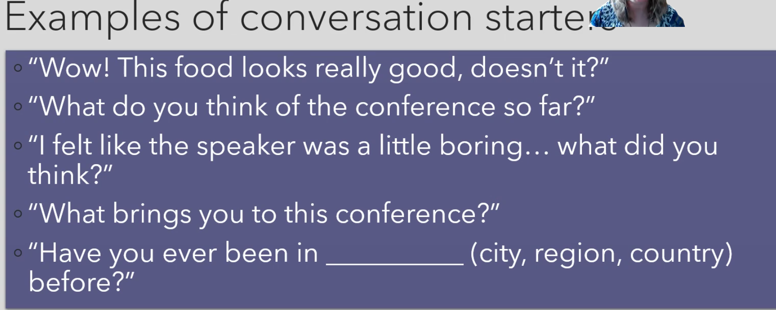
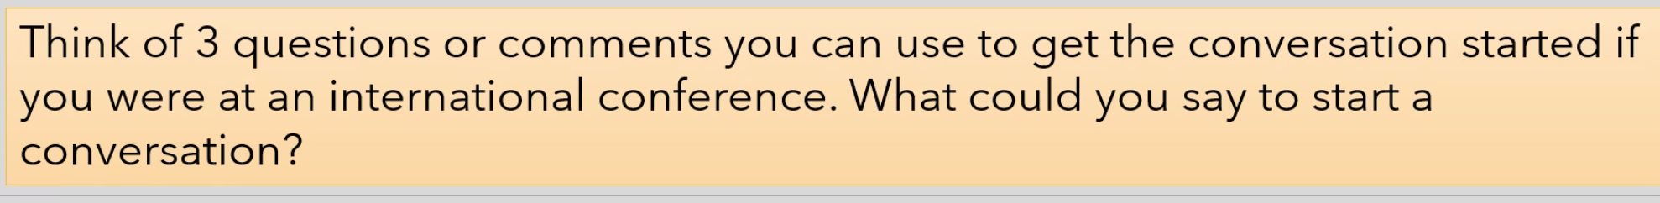
Why are you at the conference
Are you here with other people?
Is this your first time in [city]? What do you think of it?
Have you gone to this conference before?
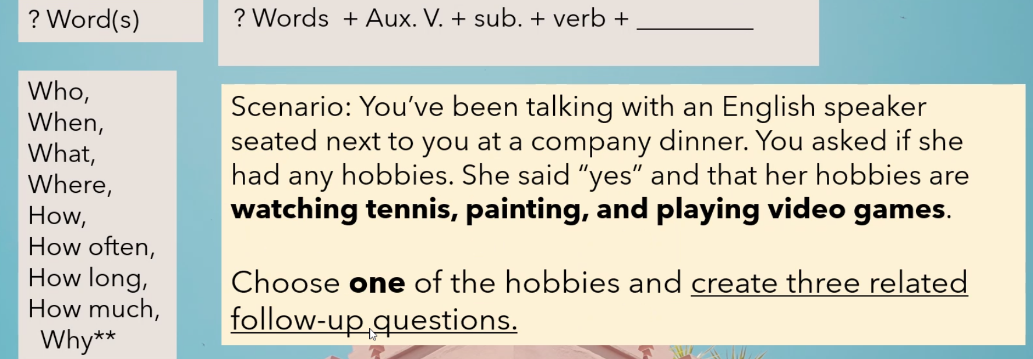

Why do you like video games?
What video games do you like?
How often do you play video games?
Whom do you play video games with?
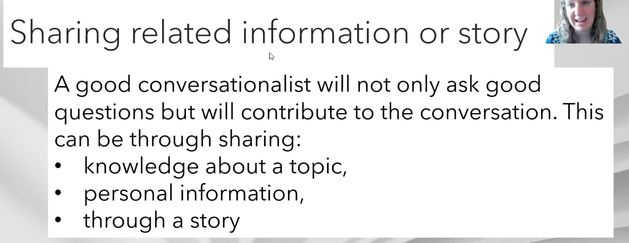
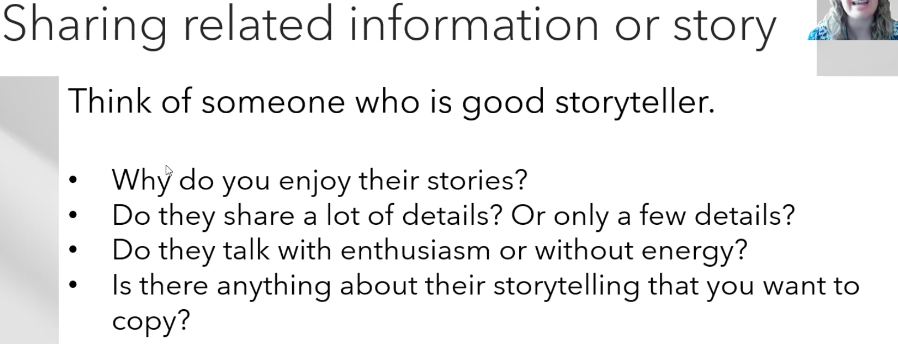
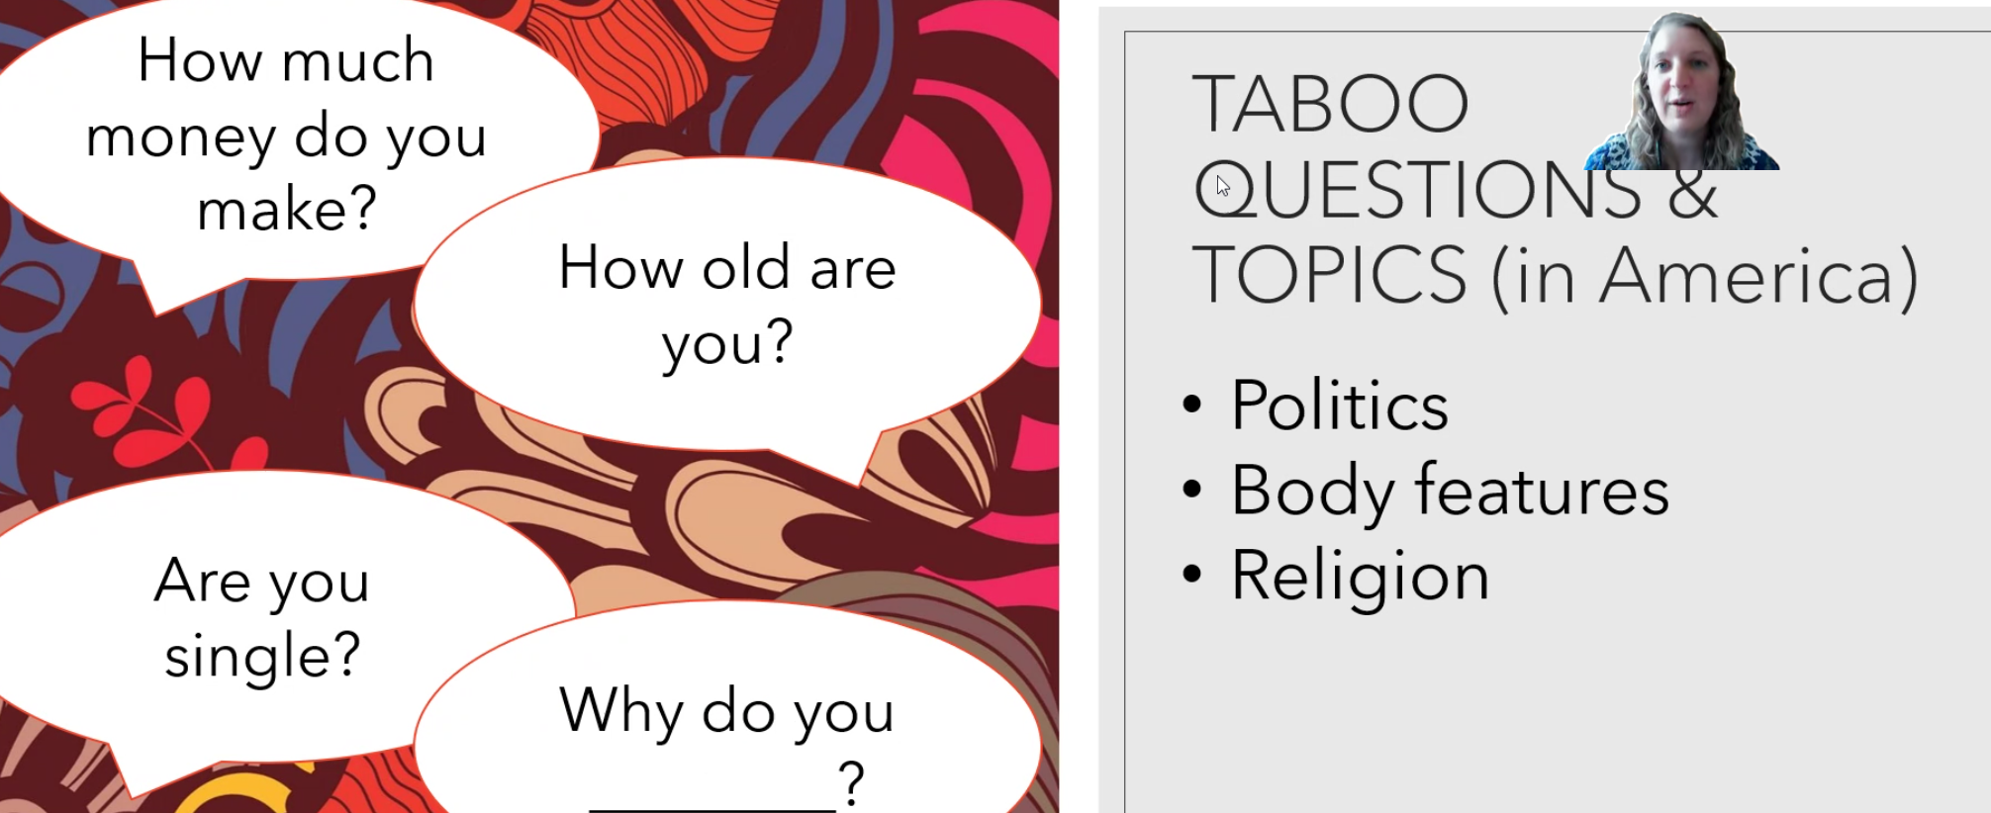
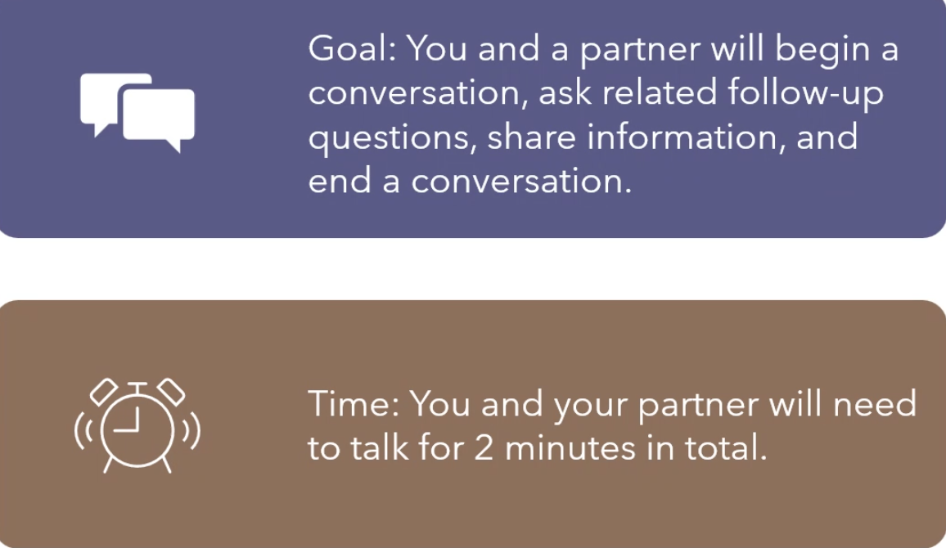
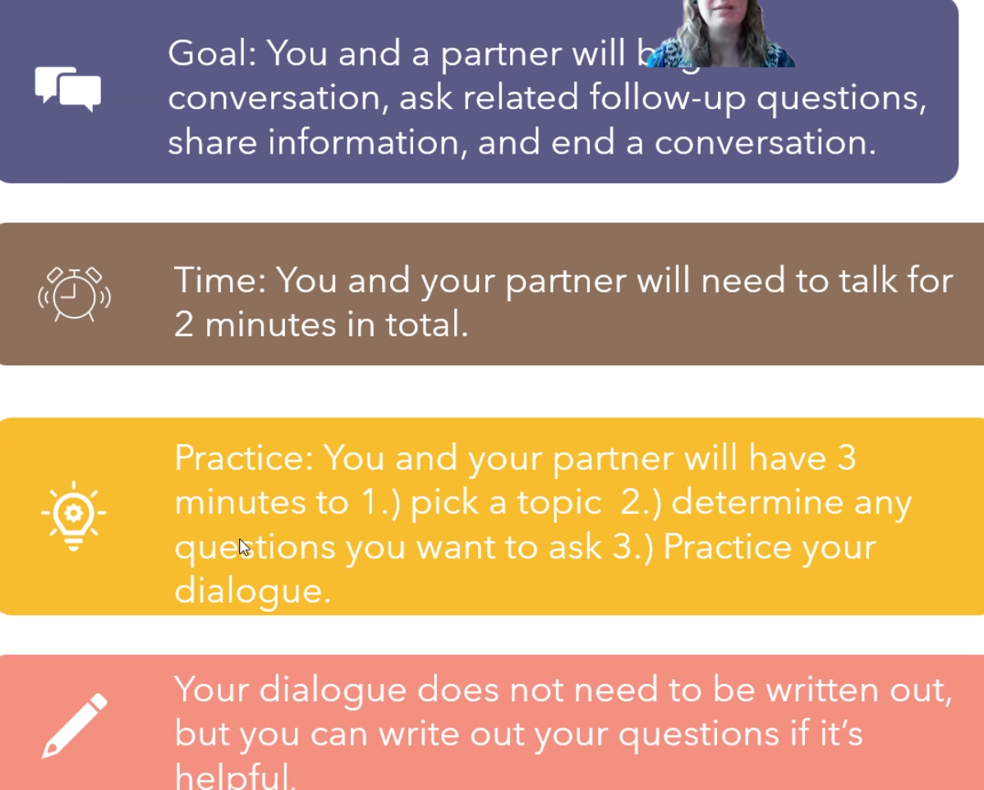

I like play video games, and I like watching TV series,

It is time to
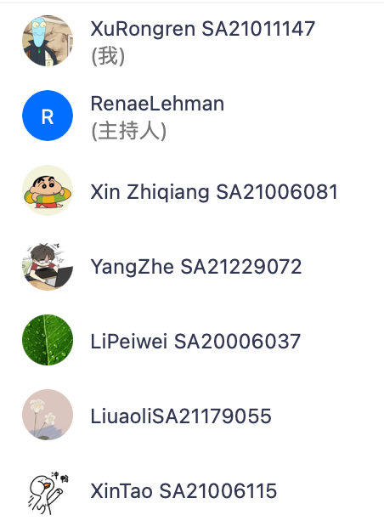

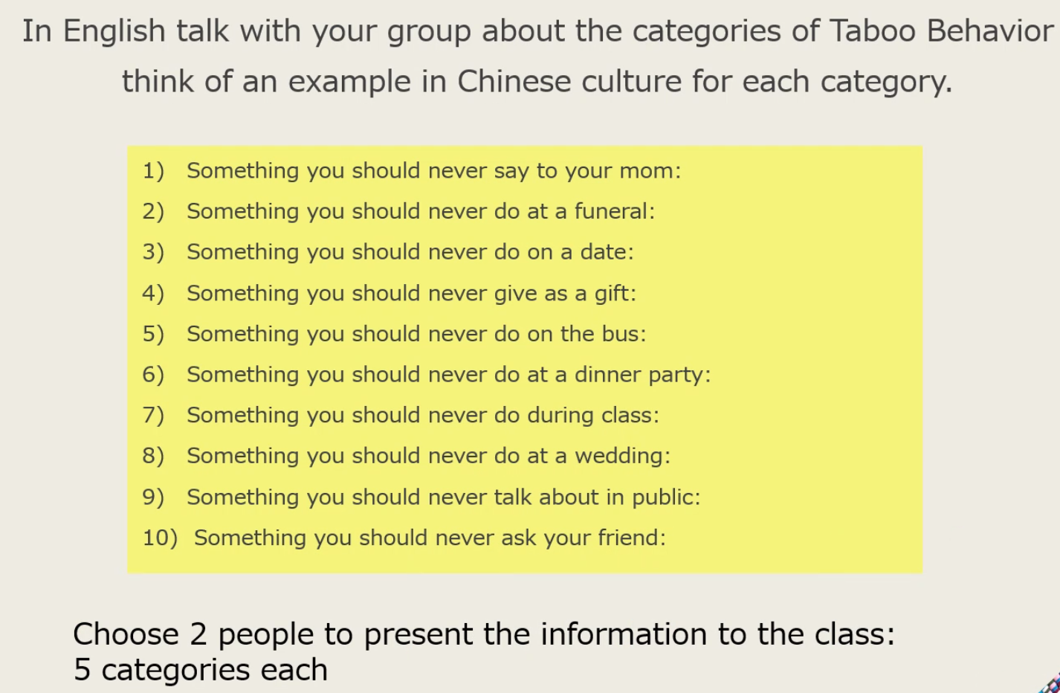
- Dirty words
- Laugh
- Always play with cellphone
- Clock
- Eat food with semll/ call loudly
- Nothing
- Talking loudly/eat food
- Say unlucky words
- Privacy/politics
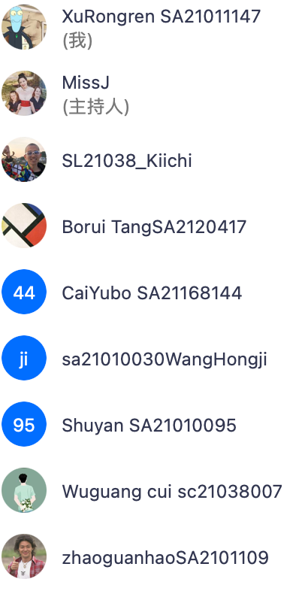
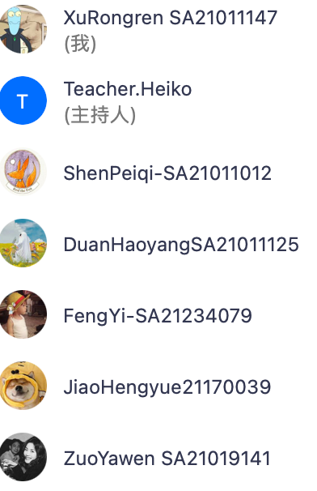

keeping healthy
Successful graduation
Driver license
Good job
academic paper
passion for life

great friends
nice family

people with disabilities

he accepts his life and enjoy it

